**Lab Cycle 1**

**CO1: Explore markup languages features and create interactive web pages using them.**

**Program # 1**

Create a simple HTML webpage for your CV to showcase the use of text formatting, image embedding, tables, Lists and links within a page and link to another web page.

**PROGRAM CODE:**

**cvpage1.html**

<html><body><center><img src="neww.jpg" alt="image" width="200" height="200"><h1>GOKUL RAJ C</h1></center><h1 style="color:white; background:black;">About Me</h1><h1>MCA Student at Muthoot Institute Of Science And Technology</h1><h1 style="color:white; background:black;">Personal Details</h1><ul><li><h1>Email:gokulrajc63@gmail.com</h1></li><li><h1>Phone:9061393951</h1></li><li><h1>DOB:11-April-2003</h1></li><li><h1>Address:Chavarukulangara(H),Periyappuram P.O,Pampakkuda,Onkkoor,Ernakulam,686667</h1></li></ul><h1 style="color:white; background:black;">Skills</h1><ul><li><h1>C,C++</h1></li><li><h1>PHP,HTML,MySql</h1></li><li><h1>CSS,JavaScript</h1></li><li><h1>Java,Python</h1></li></ul><center><h2><a href="cvpage2.html">next page</a></h2></center></body></html>

**cvpage2.html:**

<html><style>table, th, td { border: 3px solid black; border-collapse: collapse;}</style><body><h1 style="color:white; background:black;">Education</h1><table style="width:80%"><tr><th><h1>Course</h1></th><th><h1>School/College</h1></th><th><h1>Percentage</h1></th><th><h1>Year</h1></th></tr><tr><td><h1>Degree-BCA</h1></td><td><h1>BPC College Piravom</h1></td><td><h1>79.77</h1></td><td><h1>2024</h1></td></tr><tr><td><h1>+2-Computer Science</h1></td><td><h1>MKM HSS Piravom</h1></td><td><h1>93.75</h1></td><td><h1>2021</h1></td></tr><tr><td><h1>10 th</h1></td><td><h1>Fatima Central School</h1></td><td><h1>85.6</h1></td><td><h1>2019</h1></td></tr></table><h1 style="color:white; background:black;">Projects</h1><ul><li><h1>Mini Project:Garage4 Online Car Rent Website Using PHP,MySql</h1></li><li><h1>Main Project:Authentify DeepFake Image Detection Using Machine Learning</h1></li></ul><h1 style="color:white; background:black;">Languages</h1>

<ul><li><h1>English</h1></li><li><h1>Malayalam</h1></li></ul><center><h2><a href="cvpage1.html">previous page</a></h2></center></body></html>

**OUTPUT:**

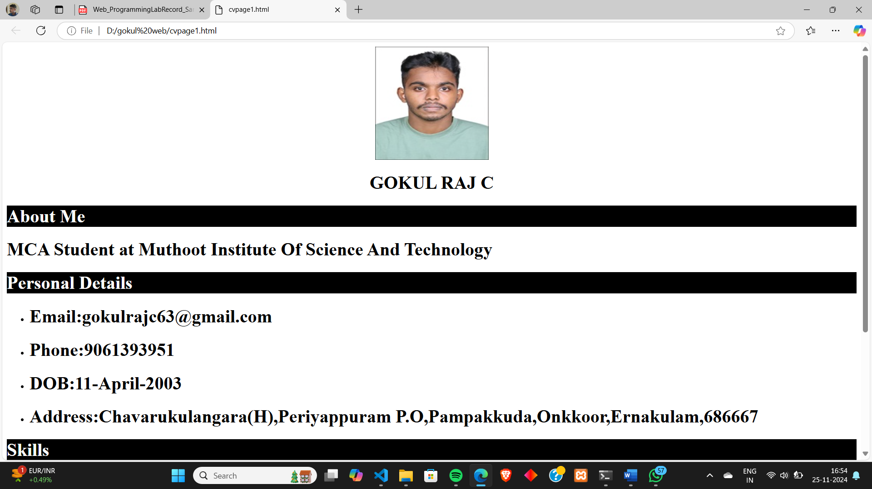

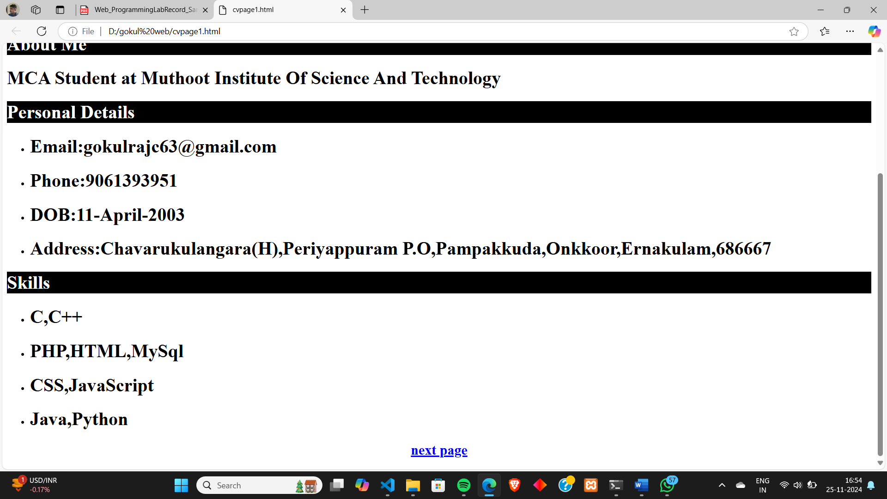

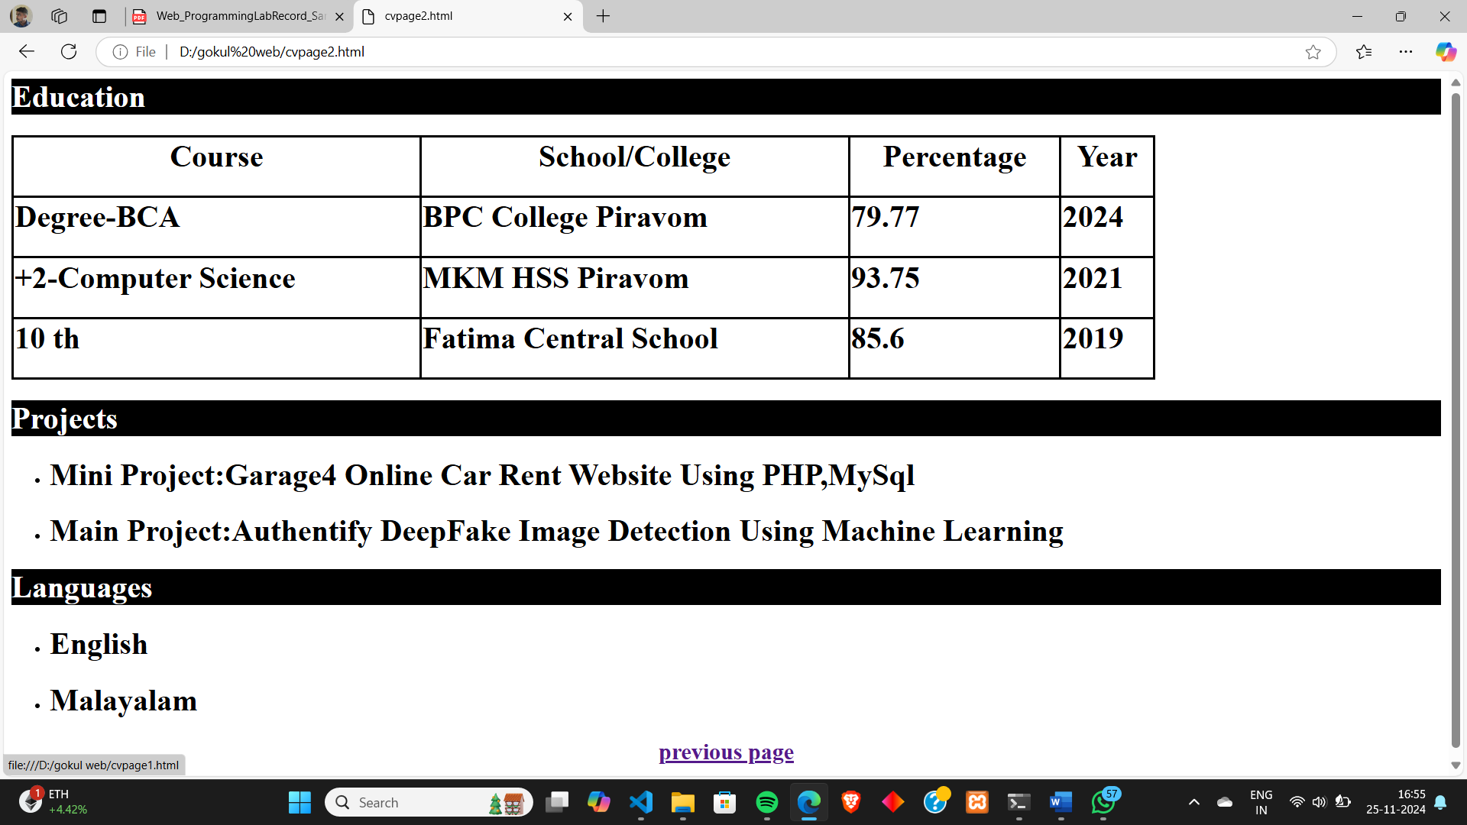

**Program # 2**

Create a web page of two parts, Part 1: MCA student registration form Part 2: Webpage of the college.

Use frames and various form elements to create the webpage.

**PROGRAM CODE:**

**mcaregistration.html**

<html><head><title>Mca Registation</title></head><frameset cols="40%,60%" scrolling="no" noresize><frame name="one" src="form.html"></frame><frame name="two" src="web.html"></frame></html>

**form.html**

<html><head><title>Registration Form</title></head><body><center><h2 style="background-color:red;color:white" >MCA STUDENT REGISTRATION FORM</h2><form><br><h2><label for="fname">First Name:</label><input type="text" name="fname"><br><br><label for="lname">Last Name:</label><input type="text" name="lname"><br><br><label for="email">Email:</label><input type="text" name="email"><br><br><label for="dob">DOB:</label><input type="date" name="dob"><br><br><label for="gender">Gender:</label>

<input type="radio" name="gender" value="male">Male<input type="radio" name="gender" value="female">Female<br><br><label for="phone">Phone No:</label><input type="text" name="phone"><br><br><label for="dropdown">Course In Degree:</label><select name="dropdown"><option value="select any" selected>select any</option><option value="bca">BCA</option><option value="bba">BBA</option><option value="bcom">BCOM</option><option value="bscmp">Bsc Computer Science</option><option value="bscphy">Bsc Physics</option><option value="bscmath">Bsc Maths</option></select><br><br><label for="adtype">Admission Type:</label><input type="radio" name="adtype" value="Merit">Merit<input type="radio" name="adtype" value="Management">Management<br><br><label for="pass">Password:</label><input type="password" name="pass"><br><br><input type="submit" name="submit" value="Submit"><input type="reset" name="reset" value="Reset"><input type="button" name="ok" value="Ok"></h2></form></center></body></html>

**web.html**

<html><head><title>Muthoot Institute of Technology and Science (MITS)</title></head><body><h1 style="background-color:red;color:white"><b><center>MUTHOOT INSTITUTE OF SCIENCE AND TECHNOLOGY(MITS)</center><b></h1>

<center><img src="OIP (1).JFIF" alt="muthoot" height="100" width="800"></center>

<center><h1 style="background-color:red;color:white">About</h1></center><p>Muthoot Institute of Technology and Science (MITS) is promoted by Muthoot M. George Institute of Technology, a Section 25 Company within the Muthoot Group. MITS is a self financing technical institution offering postgraduate and undergraduate engineering programmes, situated in the industrial suburb of Kochi, close to the Smart City and Info Park, approximately 15 kms from Vytilla Junction towards Muvattupuzha on the Cochin Madurai National Highway.</p><center><img src="OIP.JFIF" alt="muthoot" height="200" width="1000"></center><h2 style="background-color:red;color:white">Departments<h2><ul><li>Btech</li><li>Mtech</li><li>Mca</li></ul><h2 style="background-color:red";><h2><h2 style="background-color:red;color:white">B.Tech</h2><ul><li>CIVIL ENGINEERING</li><li>COMPUTER SCIENCE & ENGINEERING</li><li>ELECTRONICS & COMMUNICATION ENGINEERING</li><li>ELECTRICAL & ELECTRONICS ENGINEERING</li><li>MECHANICAL ENGINEERING</li><li>CSE (ARTIFICIAL INTELLIGENCE)</li><li>ARTIFICIAL INTELLIGENCE & DATA SCIENCE</li><li>CYBER SECURITY</li></ul><h2 style="background-color:red;color:white">M.Tech</h2><ul><li>ARTIFICIAL INTELLIGENCE & DATA SCIENCE</li><li>CYBER SECURITY</li></ul><h1 style="background-color:red;color:white"><b><center>Gallery</center><b></h1><img src="SAVE_20200601_145736.jpg" alt="muthoot" height="500" width="850"></body></html>

**OUTPUT:**



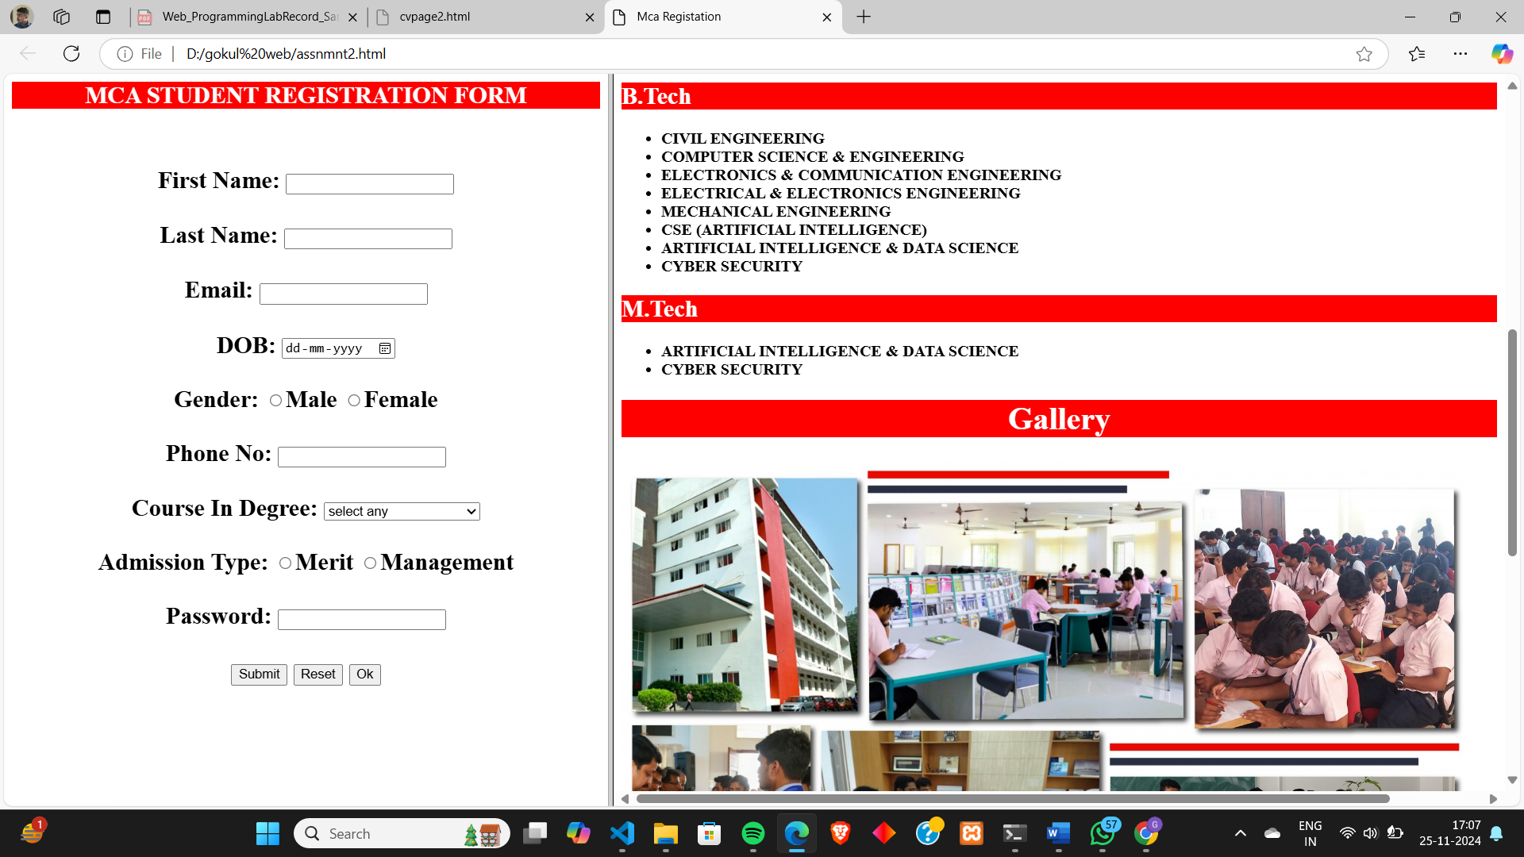

**Program # 3**

Create a webpage about your hometown and its tourist attractions using Html, and External, Internal, and inline CSS. The following elements should be included in the webpage:

1. Html text formatting
2. Links to Wikipedia pages for further references
3. External, Internal, and Inline CSS
4. CSS should include font colour, positioning, background colours, text alignment etc.
5. Images of the hometown and its attractions.
6. Usage of div elements for styling

**PROGRAM CODE:**

**hometown.html**

<html><title></title><head><link rel="stylesheet" href="hometown.css"><style>div.div1 { position: relative; height: 500px; /* Full height */ width: 100vw; /* Full width */ overflow: hidden;}img.img1 { width: 100%; height: 100%; object-fit: cover; /* Cover the entire container */}div.text { position: absolute; top: 50%; left: 50%; transform: translate(-50%, -50%); /* Center the text */ color: white; /* Text color */ text-align: center; /* Center the text */ z-index: 10; /* Make sure text is on top */ font-size: 3em; }}

</style></head><body><div class="div1"><div class="text"><h1>PIRAVOM</h1></div><img src="piravom.jpg" alt="Description of the image" class="img1"></div><center><h1 style="background-color:#089cc7;color:white">About Piravom</h1></center><p><i><h2 style="margin: 30px;">Piravom is a municipality in the Ernakulam district, Kochi, Kerala, India. The block is located 22 km south of the district collectorate near the Thrikkakara and 162 km north of the capital of the state, Thiruvananthapuram. According to the Census report, the block has a population of around 27,229 people. The population density is around 927/km2.Piravom is popular, being an urban area, and is home to various temples and heritage places. Its strategic location makes it a hub for all commercial activities in the city of Kochi. The block is also reputed for good hotels and restaurants, and it is very popular with the Muvattupuzha River. The banks of the river make way for an ideal cluster of tourist places here, including various bridges and shorelines. </h2></i></p><center><h1 style="background-color:#089cc7;color:white">Places To Visit In Piravom</h1></center><div class="card-container"> <div class="card"> <img src="pazhoor.jpg" alt="Image 1" class="card-image"> <div class="card-text"> <h2>Perumthrkkovil Pazhor</h2> <a href="https://en.wikipedia.org/wiki/Pazhoor_Padipura">view more</a> </div> </div> <div class="card"> <img src="Piravom_Valiya_Pally.jpg" alt="Image 2" class="card-image"> <div class="card-text"> <h2>Piravom Valiyapally</h2> <a href="https://en.wikipedia.org/wiki/St._Mary%27s_Orthodox_Syrian_Cathedral,_Piravom">view more</a>

</div> </div> <div class="card"> <img src="attutheeram.jpg" alt="Image 3" class="card-image"> <div class="card-text"> <h2>Aattutheeram Park </h2> <a href="https://www.youtube.com/watch?v=R4ea5lc4z2w">view more</a> </div> </div> </div><br><br><div class="card-container"> <div class="card"> <img src="areekal.jpg" alt="Image 1" class="card-image"> <div class="card-text"> <h2>Areeckal Waterfalls</h2> <a href="https://www.tripadvisor.in/Attraction_Review-g297633-d12177011-Reviews-Areekkal_Water_Falls-Kochi_Cochin_Ernakulam_District_Kerala.html">view more</a> </div> </div> <div class="card"> <img src="kochareekkal.webp" alt="Image 2" class="card-image"> <div class="card-text"> <h2>Kochareekkal Caves</h2> <a href="https://www.tripuntold.com/kerala/ernakulam/kochareekkal-caves/">view more</a> </div> </div> <div class="card"> <img src="koorumala.jpg" alt="Image 1" class="card-image"> <div class="card-text"> <h2>Koorumala View Point</h2> <a href="https://www.youtube.com/watch?v=UD06ZX4dm4Y">view more</a> </div> </div> </div></body></html>

**hometown.css**

.card-container { display: flex; gap: 20px; /* Space between cards */ padding: 15px;}.card { background-color: white; /* Card background color */ border: 1px solid #ccc; /* Card border */ border-radius: 8px; /* Rounded corners */ width: 480px; /* Fixed width for equal sizing */ overflow: hidden; /* Hide overflow */ box-shadow: 0 4px 8px rgba(0, 0, 0, 0.1); /* Card shadow */}.card-image { width: 100%; /* Full width of the card */ height: 300px; /* Fixed height for images */ object-fit: cover; /* Cover the area without distortion */}.card-text { padding: 15px; /* Padding for text */ text-align: center; /* Center the text */}

**OUTPUT:**

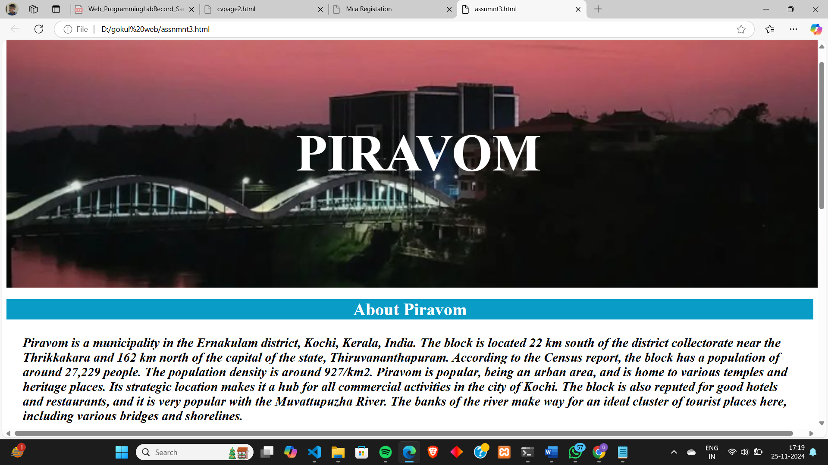

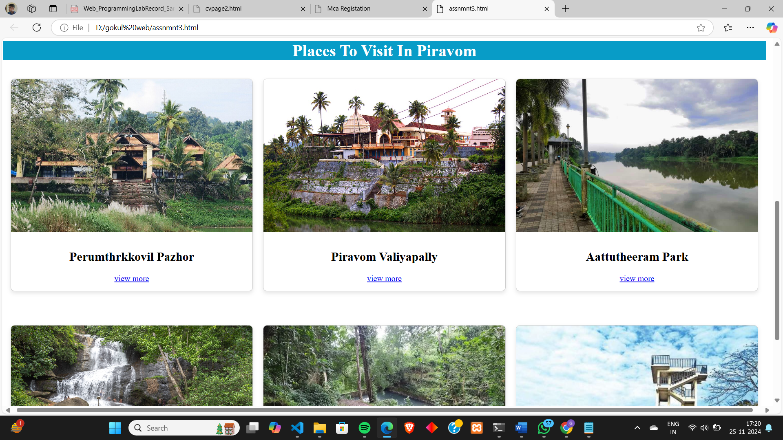

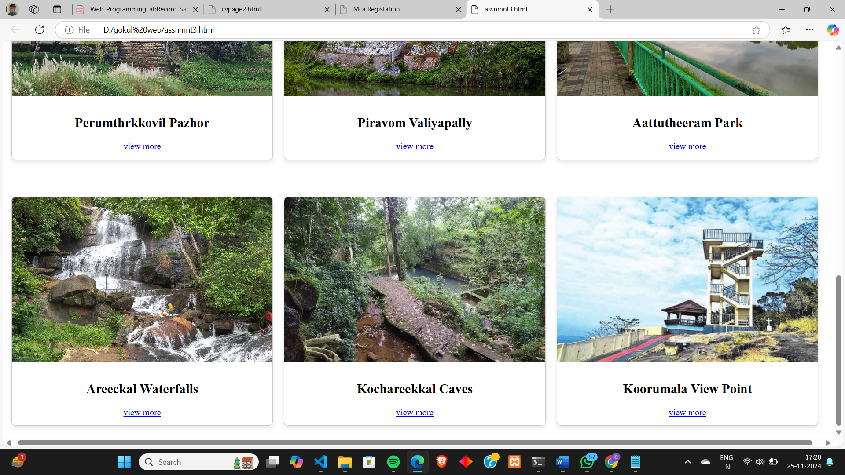

**Program # 4**

Create MITS college Website with the help of frames, style sheets, background colours, images, tables, and lists. Create multiple webpages which are easily navigable by hyperlinks. Apply style sheets as well as floating, mixed, and navigation frames to design the webpages.

**PROGRAM CODE:**

**mainweb.html**

<html>

<frameset cols="30%,70%">

<frameset rows="30%,70%">

<frame src="login.html">

<frame src="registration.html">

</frameset>

<frame src="web.html"></frame>

</frameset>

</html>

**login.html**

<html> <head> <title>Login Form</title> </head> <style> table, th, td { border: 5px solid black; border-collapse: collapse; } </style> <body style="background-color:rgb(169, 202, 237);"> <center> <h2 style="background-color:red;color:white" >STUDENT LOGIN FORM</h2> <form> <table border="2" style="width:400"> <tr style="height:40"> <td><label for="fname">Email:</label></td> <td><input type="text" name="email"></td> </tr> <tr style="height:40"> <td><label for="pass">Password:</label></td> <td><input type="password" name="pass"><br><br></td> </tr> <tr style="height:40"> <td colspan="2"><center><input type="submit" name="submit" value="Submit"></center></td> </tr> </table> </form> </center> </body> </html>

**registration.html**

<html>

<head>

<title>Registration Form</title>

</head>

<body style="background-color:rgb(169, 202, 237);">

<center>

<form>

<h2 style="background-color:red;color:white">STUDENT REGISTRATION FORM</h2>

<label for="fname">First Name:</label>

<input type="text" name="fname"><br><br>

<label for="lname">Last Name:</label>

<input type="text" name="lname"><br><br>

<label for="email">Email:</label>

<input type="text" name="email"><br><br>

<label for="gender">Gender:</label>

<input type="radio" name="gender" value="male">Male

<input type="radio" name="gender" value="female">Female<br><br>

<label for="phone">Phone No:</label>

<input type="text" name="phone"><br><br>

<label for="course">Course:</label>

<input type="checkbox" name="course" value="cse">Btech CS

<input type="checkbox" name="course" value="civil">Btech Civil

<input type="checkbox" name="course" value="ece">Btech ECE

<input type="checkbox" name="course" value="mech">Btech Mech

<br><br>

<label for="dropdown">Course In Plus Two:</label>

<select name="dropdown">

<option value="select any" selected>select any</option>

<option value="bio science">Bio Science</option>

<option value="bio ip">Bio Ip</option>

<option value="comp science">Computer Science</option>

<option value="commerce">Commerce</option>

<option value="humanities">Humanities</option>

</select>

<br>

<br>

<label for="pass">Password:</label>

<input type="password" name="pass"><br><br>

<input type="submit" name="submit" value="Submit">

<input type="reset" name="reset" value="Reset">

<input type="button" name="ok" value="Ok">

</form>

</center>

</body>

</html>

**web.html**

<html>

<head>

<title>Muthoot Institute of Technology and Science (MITS)</title>

</head>

<body style="background-color:rgb(169, 202, 237);">

<h1 style="background-color:red;color:white"><b><center>MUTHOOT INSTITUTE OF SCIENCE AND TECHNOLOGY(MITS)</center><b></h1>

<center><img src="OIP (1).JFIF" alt="muthoot" height="100" width="800"></center>

<center><h1 style="background-color:red;color:white">About</h1></center>

<p>

Muthoot Institute of Technology and Science (MITS) is promoted by Muthoot M. George Institute of Technology, a Section 25 Company within the Muthoot Group.

MITS is a self financing technical institution offering postgraduate and undergraduate engineering programmes, situated in the industrial suburb of Kochi,

close to the Smart City and Info Park, approximately 15 kms from Vytilla Junction towards Muvattupuzha on the Cochin Madurai National Highway.

</p>

<center><img src="OIP.JFIF" alt="muthoot" height="200" width="1000"></center>

<h2 style="background-color:red;color:white">Departments<h2>

  <ul>

    <li>Btech</li>

    <li>Mtech</li>

    <li>Mca</li>

    </ul>

    <h2 style="background-color:red";><h2>

    <h2 style="background-color:red;color:white">B.Tech</h2>

    <ul>

    <li>CIVIL ENGINEERING</li>

    <li>COMPUTER SCIENCE & ENGINEERING</li>

    <li>ELECTRONICS & COMMUNICATION ENGINEERING</li>

    <li>ELECTRICAL & ELECTRONICS ENGINEERING</li>

    <li>MECHANICAL ENGINEERING</li>

    <li>CSE (ARTIFICIAL INTELLIGENCE)</li>

    <li>ARTIFICIAL INTELLIGENCE & DATA SCIENCE</li>

    <li>CYBER SECURITY</li>

    </ul>

    <h2 style="background-color:red;color:white">M.Tech</h2>

    <ul>

    <li>ARTIFICIAL INTELLIGENCE & DATA SCIENCE</li>

    <li>CYBER SECURITY</li>

    </ul>

<h1 style="background-color:red;color:white"><b><center>Gallery</center><b></h1>

    <center>

<img src="SAVE_20200601_145736.jpg" alt="muthoot" height="500" width="850">

</center>

</body>

</html>

**OUTPUT:**

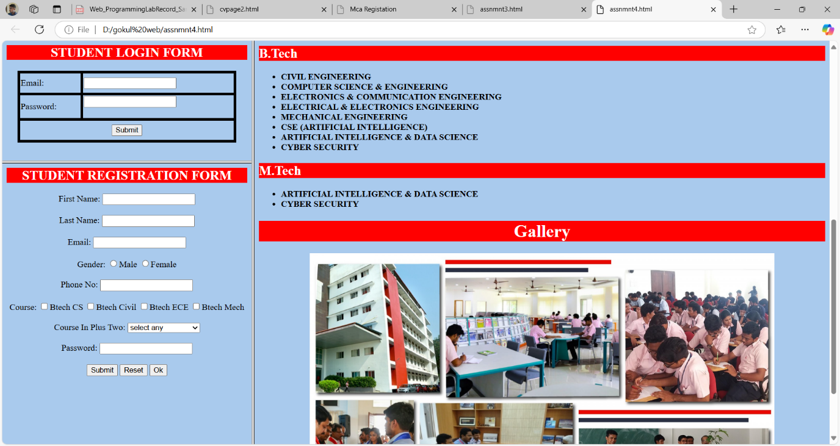

**Program # 5**

Apply positioning methods of elements on a webpage with div elements and their corresponding classes using two external stylesheets. Compare the output with absolute, and relative positioning of div elements.

**PROGRAM CODE:**

**position.html**

<html>

<head>

<style>

div.relative {

  position: relative;

  width: 500px;

  height: 500px;

  border: 3px solid #2126ad;

}

div.absolute {

  position: absolute;

  top: 550px;

  left: 10;

  width: 600px;

  height: 100px;

  border: 3px solid #ad2121;

}

</style>

</head>

<body>

<div class="relative">This div element has position: relative;</div>

  <div class="absolute">This div element has position: absolute;</div>

</body>

</html>

**OUTPUT:**

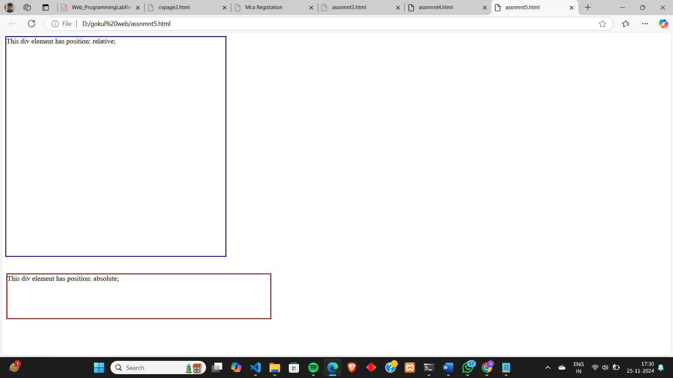

**Lab Cycle 2**

**CO2: Learn and design client-side validation using scripting languages.**

**Program # 6**

Create a HTML page to explain the use of various predefined functions in a string and math object in java script.

**PROGRAM CODE:**

**strmathfunctn.html**

<html> <h3> <form onsubmit="strfunction(event)"> <label for="stringval">Enter String:</label> <input type="text" id="stringval" name="stringval"><br><br> <input type="submit" name="submit" value="submit"> </form> </h3> <h3 id="strdemo1"></h3> <h3 id="strdemo2"></h3> <h3 id="strdemo3"></h3> <h3 id="strdemo4"></h3> <h3 id="strdemo5"></h3> <h3 id="strdemo6"></h3> <h3 id="strdemo7"></h3> <script> function strfunction(event) { event.preventDefault(); let val=document.getElementById("stringval").value; let val1=val.length; let val2=val.slice(4,8); let val3=val.substring(0,6); let val4=val.substr(2,5); let val5=val.toUpperCase(); let val6=val.toLowerCase(); let val7="hello"; let val8=val.concat(" ",val7); document.getElementById("strdemo1").innerHTML="length: " + val1;

document.getElementById("strdemo2").innerHTML="slice(4,8): " + val2; document.getElementById("strdemo3").innerHTML="substring(0,6): " + val3; document.getElementById("strdemo4").innerHTML="substr(2,5): " + val4; document.getElementById("strdemo5").innerHTML="upper case: " + val5; document.getElementById("strdemo6").innerHTML="lower case: " + val6; document.getElementById("strdemo7").innerHTML="concat hello: " + val8; } </script> <br> <h3> <form onsubmit="mathfunction(event)"> <label for="mathval">Enter Number:</label> <input type="text" id="mathval" name="mathval"><br><br> <input type="submit" name="submit" value="submit"> </form> </h3> <h3 id="mathdemo1"></h3> <h3 id="mathdemo2"></h3> <h3 id="mathdemo3"></h3> <h3 id="mathdemo4"></h3> <h3 id="mathdemo5"></h3> <h3 id="mathdemo6"></h3> <h3 id="mathdemo7"></h3> <h3 id="mathdemo8"></h3> <h3 id="mathdemo9"></h3> <h3 id="mathdemo10"></h3> <h3 id="mathdemo11"></h3> <h3 id="mathdemo12"></h3> <h3 id="mathdemo13"></h3> <script> function mathfunction(event) { event.preventDefault(); let varr=document.getElementById("mathval").value; let varr1=Math.round(varr); let varr2=Math.ceil(varr); let varr3=Math.floor(varr); let varr4=Math.trunc(varr); let varr5=Math.sign(varr); let varr6=Math.pow(8,2); let varr7=Math.sqrt(81); let varr8=Math.abs(varr); let varr9=Math.min(0, 150, 30, 20, -8, -200);

let varr10=Math.max(0, 150, 30, 20, -8, -200); let varr11=Math.random(); let varr12=Math.log(1); let varr13=Math.log10(1000); document.getElementById("mathdemo1").innerHTML="round(): " + varr; document.getElementById("mathdemo2").innerHTML="ceil(): " + varr2; document.getElementById("mathdemo3").innerHTML="floor(): " + varr3; document.getElementById("mathdemo4").innerHTML="trunc(): " + varr4; document.getElementById("mathdemo5").innerHTML="sign(): " + varr5; document.getElementById("mathdemo6").innerHTML="power(8,2): " + varr6; document.getElementById("mathdemo7").innerHTML="sqrt(81): " + varr7; document.getElementById("mathdemo8").innerHTML="abs(): " + varr8; document.getElementById("mathdemo9").innerHTML="min(0, 150, 30, 20, -8, -200): " + varr9; document.getElementById("mathdemo10").innerHTML="max(0, 150, 30, 20, -8, -200): " + varr10; document.getElementById("mathdemo11").innerHTML="random(): " + varr11; document.getElementById("mathdemo12").innerHTML="log(1): " + varr12; document.getElementById("mathdemo13").innerHTML="log10(1000):" + varr13; } </script></html>

**OUTPUT:**

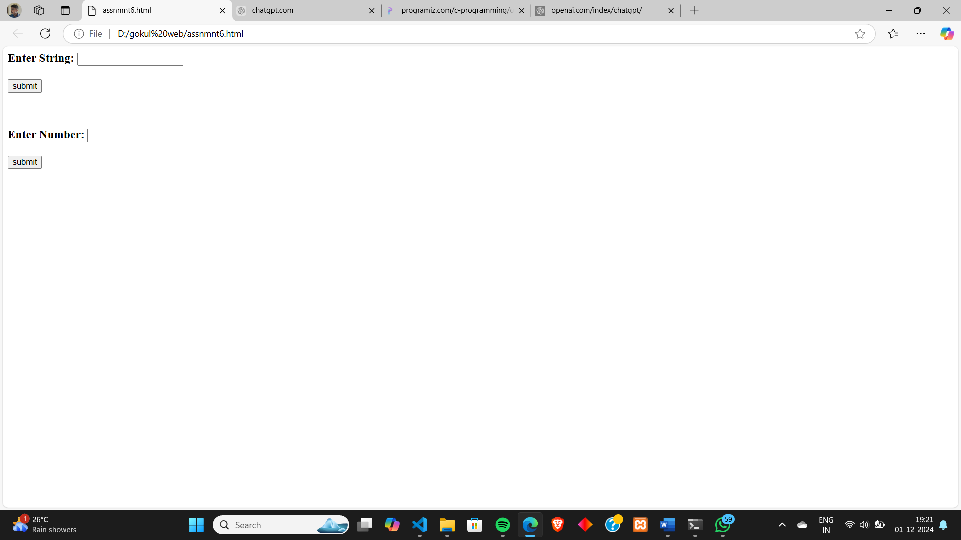

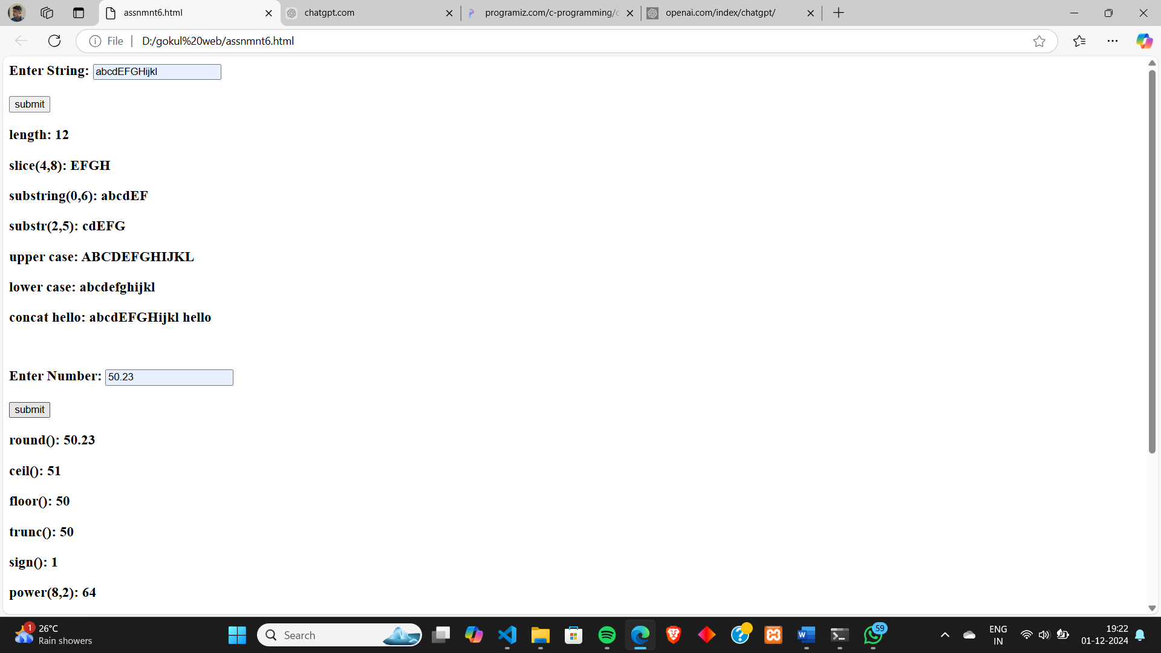

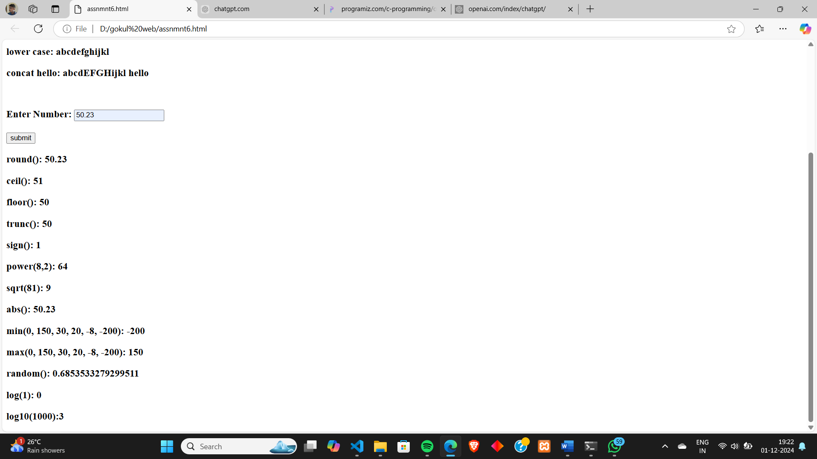

**Program # 7**

Generate the calendar using JavaScript code by getting the year from the user.

**PROGRAM CODE:**

**calender.html**

<html><head> <style> body { font-family: Arial, sans-serif; margin: 0; padding: 20px; background-color: #f4f4f9; } #calendar { margin-top: 20px; display: inline-block; text-align: center; border: 2px solid #ccc; border-radius: 8px; padding: 20px; background-color: #fff; } table { width: 100%; border-collapse: collapse; } th, td { padding: 10px; text-align: center; border: 1px solid #ddd; } th { background-color: #f4f4f4; } td { cursor: pointer; } td:hover { background-color: #f0f0f0;

} #calendar-header { font-size: 1.5em; margin-bottom: 10px; } </style></head><body><h1>Calendar</h1><p>Enter a Year and Month:</p><form id="calendar-form"> Year: <input type="number" id="year" placeholder="2024" required> Month: <input type="number" id="month" placeholder="1" min="1" max="12" required> <button type="submit">Submit</button></form><div id="calendar"></div><script> function generateCalendar(year, month) { const monthNames = ["January", "February", "March", "April", "May", "June", "July", "August", "September", "October", "November", "December"]; const firstDay = new Date(year, month - 1, 1); const lastDay = new Date(year, month, 0); const totalDays = lastDay.getDate(); const firstDayOfWeek = firstDay.getDay(); let calendarHTML = `<div id="calendar-header">${monthNames[month - 1]} ${year}</div>`; calendarHTML += "<table><tr><th>Sun</th><th>Mon</th><th>Tue</th><th>Wed</th><th>Thu</th><th>Fri</th><th>Sat</th></tr><tr>"; for (let i = 0; i < firstDayOfWeek; i++) { calendarHTML += "<td></td>"; } for (let day = 1; day <= totalDays; day++) { if ((firstDayOfWeek + day - 1) % 7 === 0 && day !== 1) { calendarHTML += "</tr><tr>"; } calendarHTML += `<td>${day}</td>`; } calendarHTML += "</tr></table>"; document.getElementById("calendar").innerHTML = calendarHTML;}document.getElementById("calendar-form").addEventListener("submit", function (event) {

event.preventDefault(); const year = parseInt(document.getElementById("year").value); const month = parseInt(document.getElementById("month").value); if (!year || !month || month < 1 || month > 12 || year < 1000 || year > 9999) { alert("Please enter a valid year (1000-9999) and month (1-12)."); return; } generateCalendar(year, month);});</script></body></html>

**OUTPUT:**

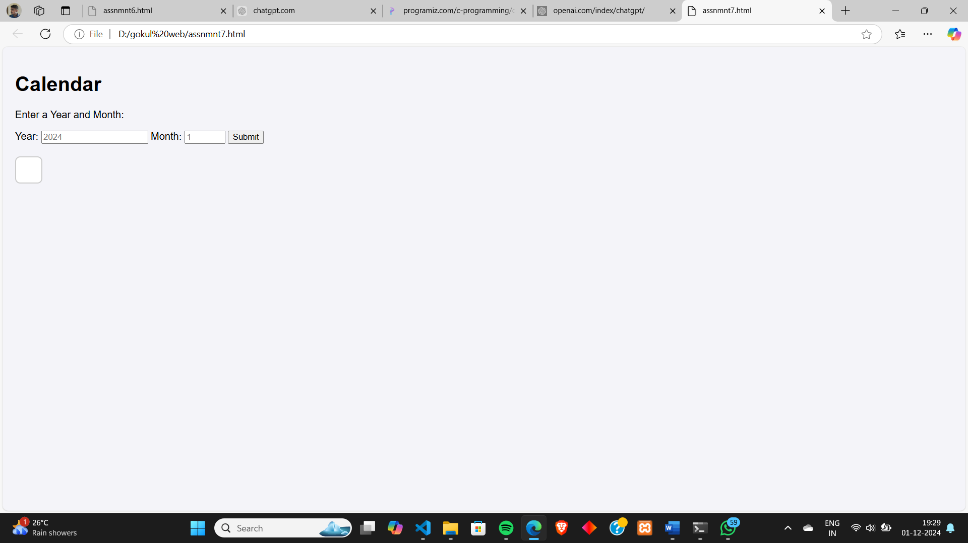

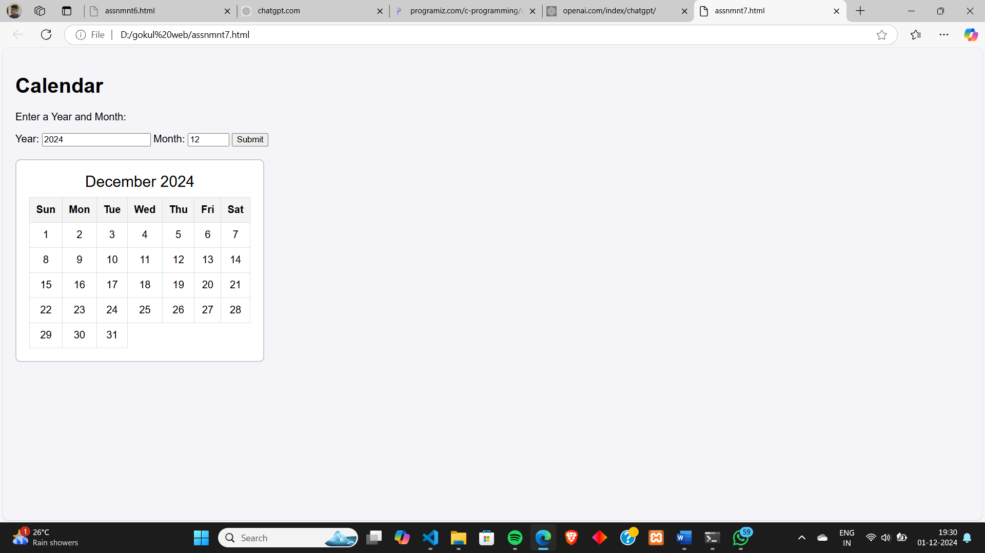

**Program # 8**

Create a program using the JavaScript Event Listener to add multiple events on the same button.

**PROGRAM CODE:**

**buttonevent.html**

<html><head> <style> #Button { padding: 10px 20px; font-size: 16px; cursor: pointer; } </style></head><body><button id="Button">Click Here</button<script>const button = document.getElementById('Button');button.addEventListener('click', function() { alert("Button was clicked!");});button.addEventListener('mouseenter', function() { button.style.backgroundColor = 'lightgreen'; console.log("Mouse entered the button!");});button.addEventListener('mouseleave', function() { button.style.backgroundColor = ''; console.log("Mouse left the button!");}); </script></body></html>

**OUTPUT:**

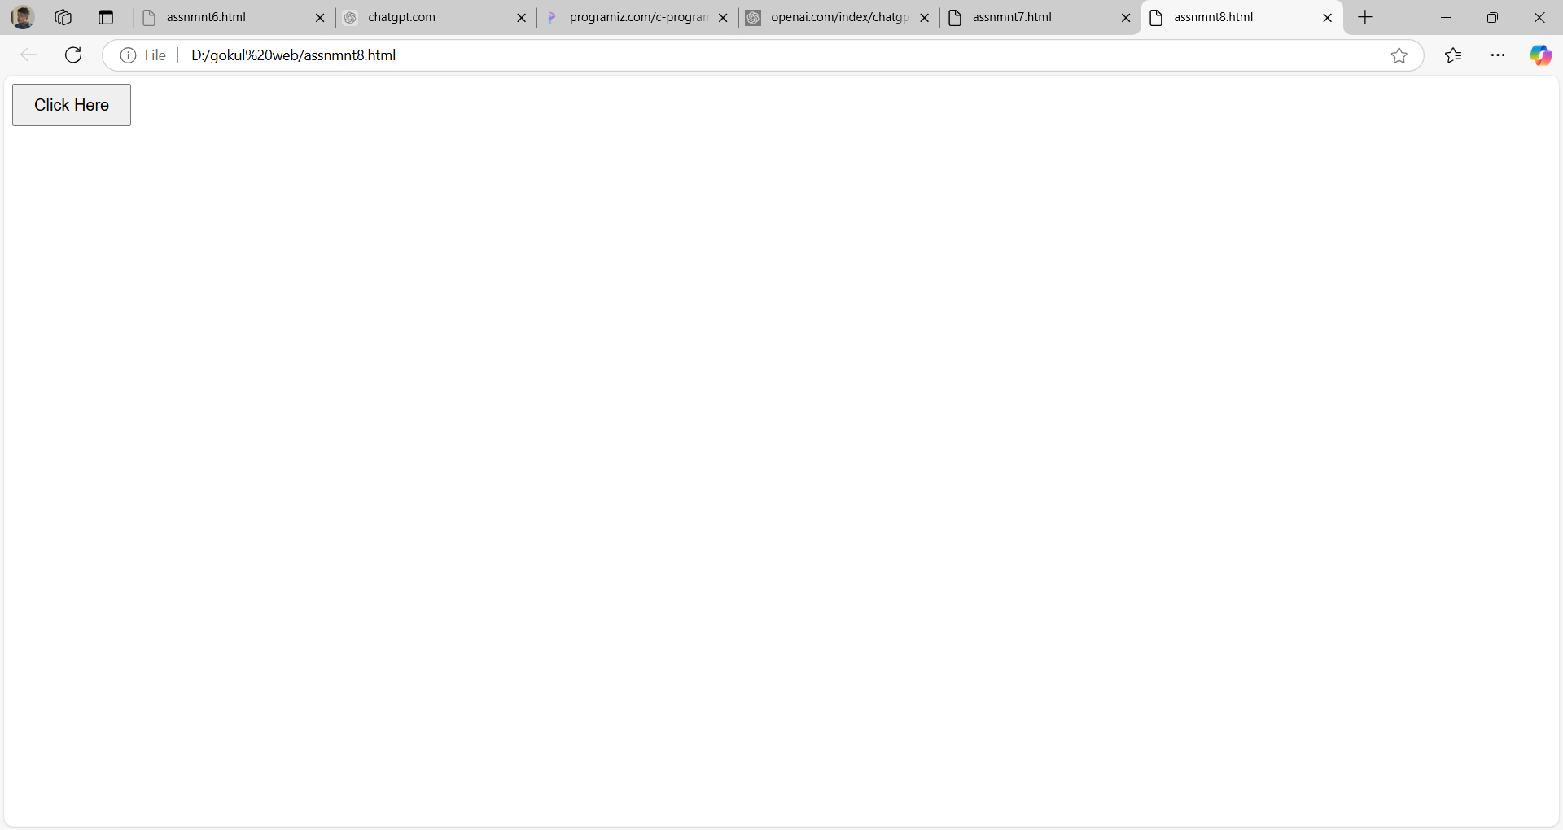

//mouse hover

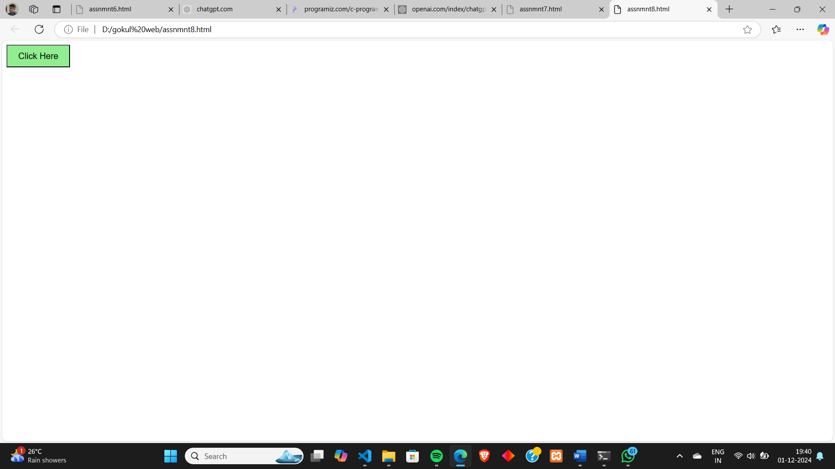

//mouse click

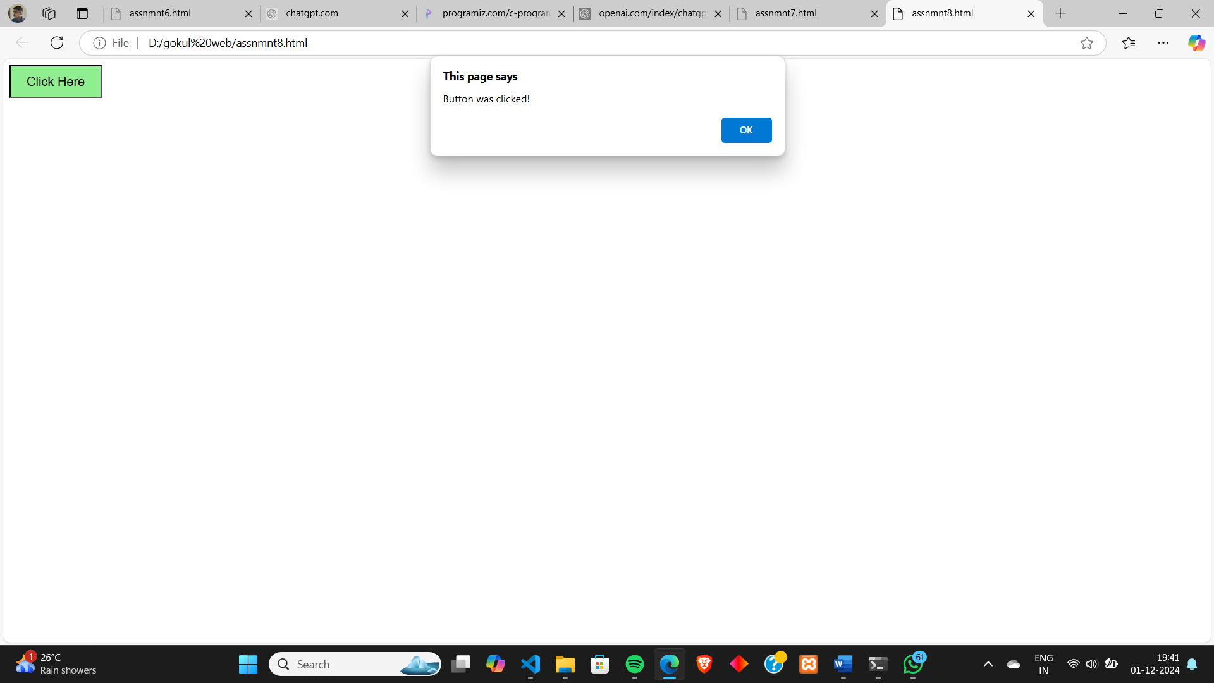

**Program # 9**

Develop a JavaScript Event Handling mechanism to change the background colour of a HTML page

**PROGRAM CODE:**

**backgroundevent.html**

<html><head> <style> body { font-family: Arial, sans-serif; text-align: center; margin-top: 100px; } button { padding: 10px 20px; font-size: 16px; cursor: pointer; } div.div1 { position: relative; height: 50px; width: 50vw; overflow: hidden; } img.img1 { width: 50%; height: 50%; object-fit: cover; } div.text { position: absolute; top: 50%; left: 50%; transform: translate(-50%, -50%); color: white; text-align: center; z-index: 10; font-size: 3em; } </style></head><body> <div class="card-container"> <div class="card"> <img src="pazhoor.jpg" alt="Image 1" class="card-image">

<div class="card-text"> <button id="colorButton">Change Background Color</button> </div> </div> </div><script>const colorButton = document.getElementById('colorButton');const colors = ['#FF5733', '#33FF57', '#3357FF', '#FF33A1', '#FFD700'];

colorButton.addEventListener('click', function() { const randomIndex = Math.floor(Math.random() * colors.length); document.body.style.backgroundColor = colors[randomIndex];});</script></body></html>

**OUTPUT:**

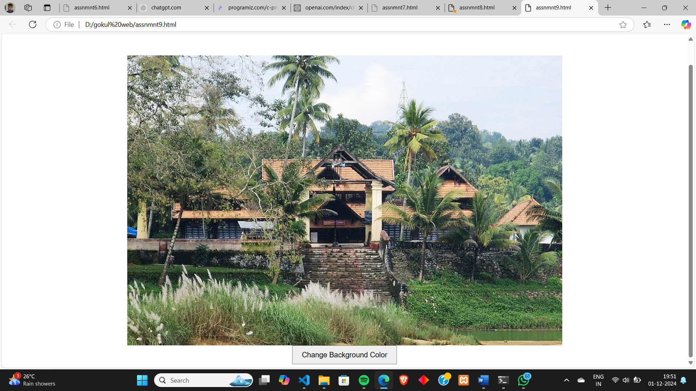

//when button is clicked

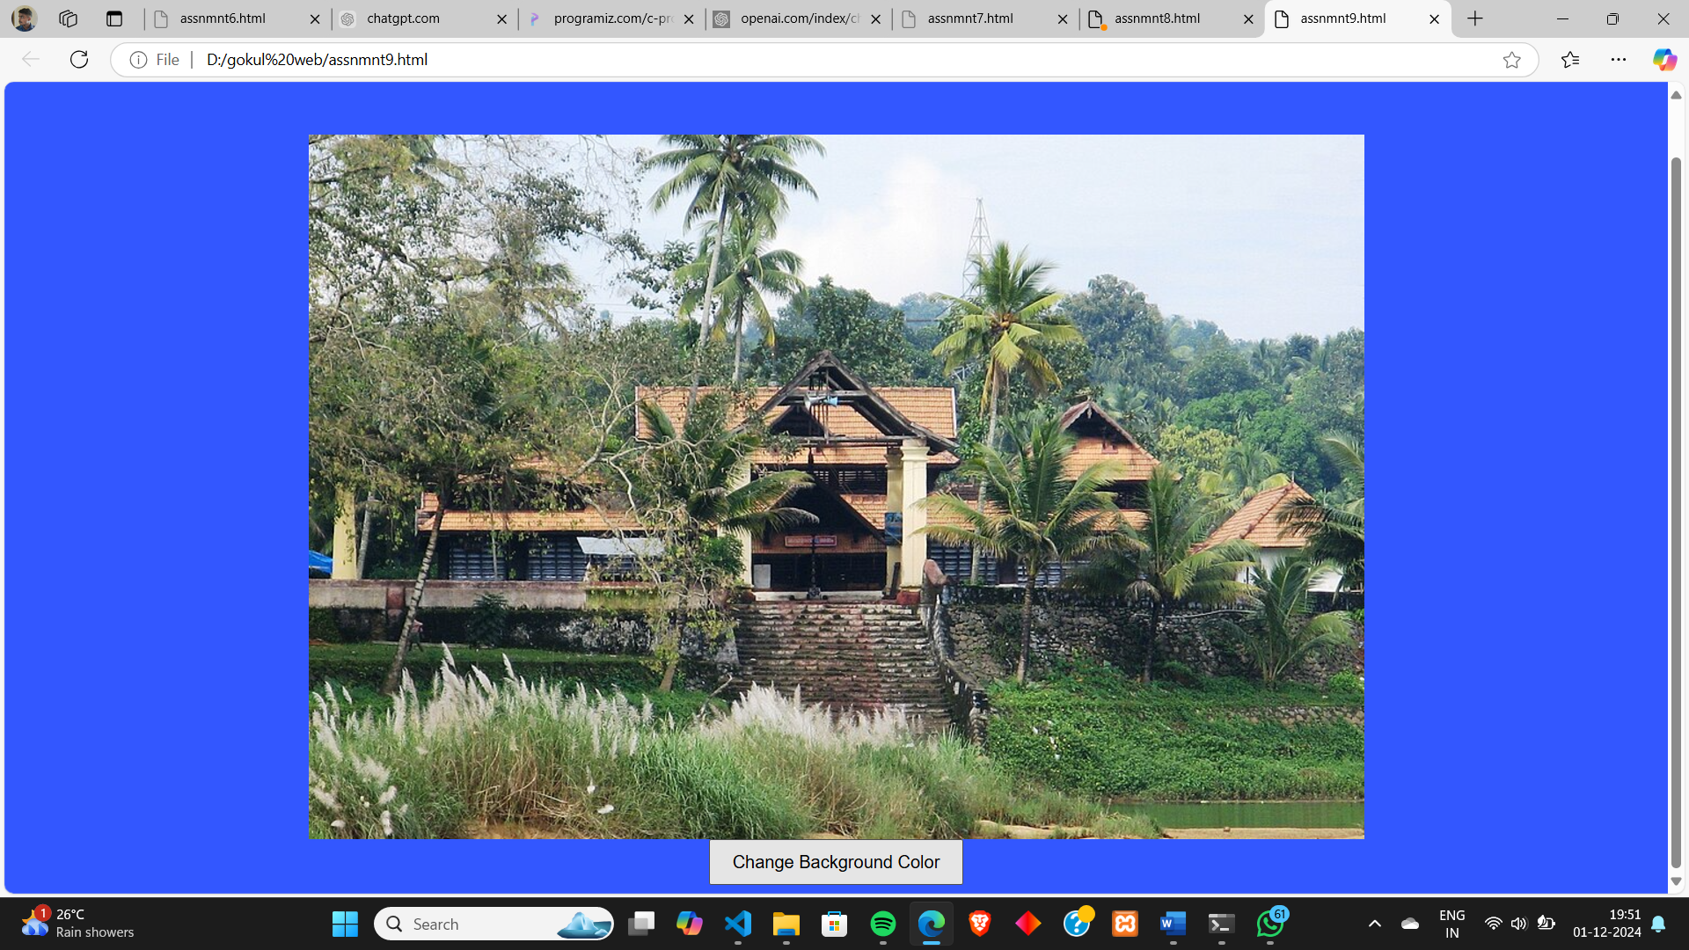

**Program # 10**

Create a HTML page to display a new image and text when the mouse comes over the existing content in the page using JavaScript Event Handling mechanism.

**PROGRAM CODE:**

**newimageevent.html**

<html><head> <style> body { font-family: Arial, sans-serif; text-align: center; margin-top: 50px; } #content { padding: 50px; background-color: lightgray; width: 300px; margin: 0 auto; cursor: pointer; } #newContent { display: none; padding: 20px; background-color: lightblue; margin-top: 20px; } #newImage { width: 100%; max-width: 300px; height: auto; } h2 { color: #333; } </style></head><body> <div id="content"> <h2>Hover over this area</h2> </div> <div id="newContent"> <h2>Here is the new image</h2> <img id="newImage" src="attutheeram.jpg" alt="New Image"> </div>

<script> const content = document.getElementById('content'); const newContent = document.getElementById('newContent'); content.addEventListener('mouseenter', function() { newContent.style.display = 'block'; }); content.addEventListener('mouseleave', function() { newContent.style.display = 'none'; }); </script></body></html>

**OUTPUT:**

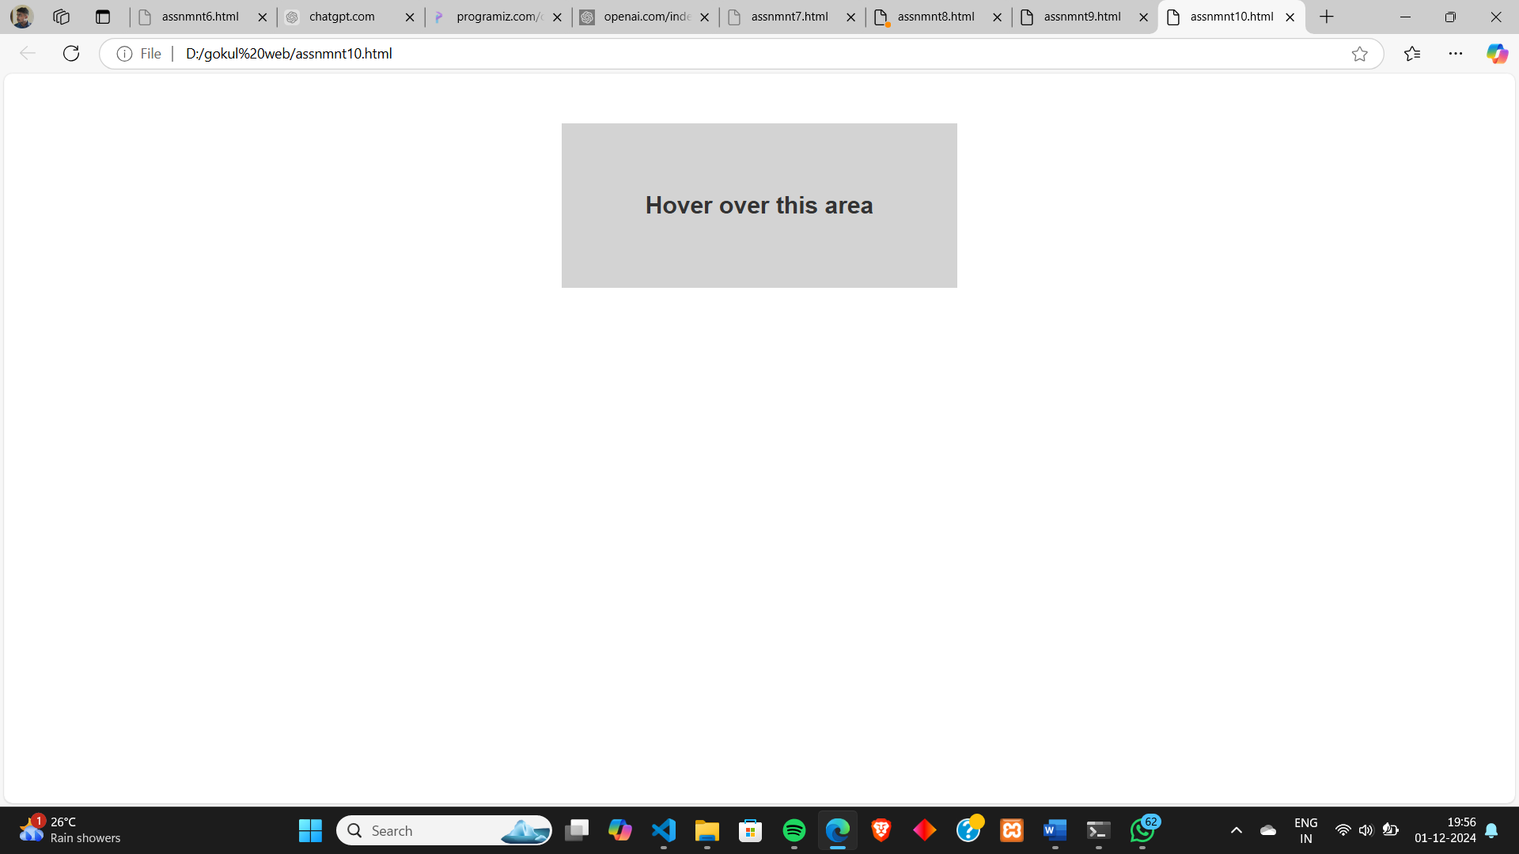

//when mouse is hovered over button

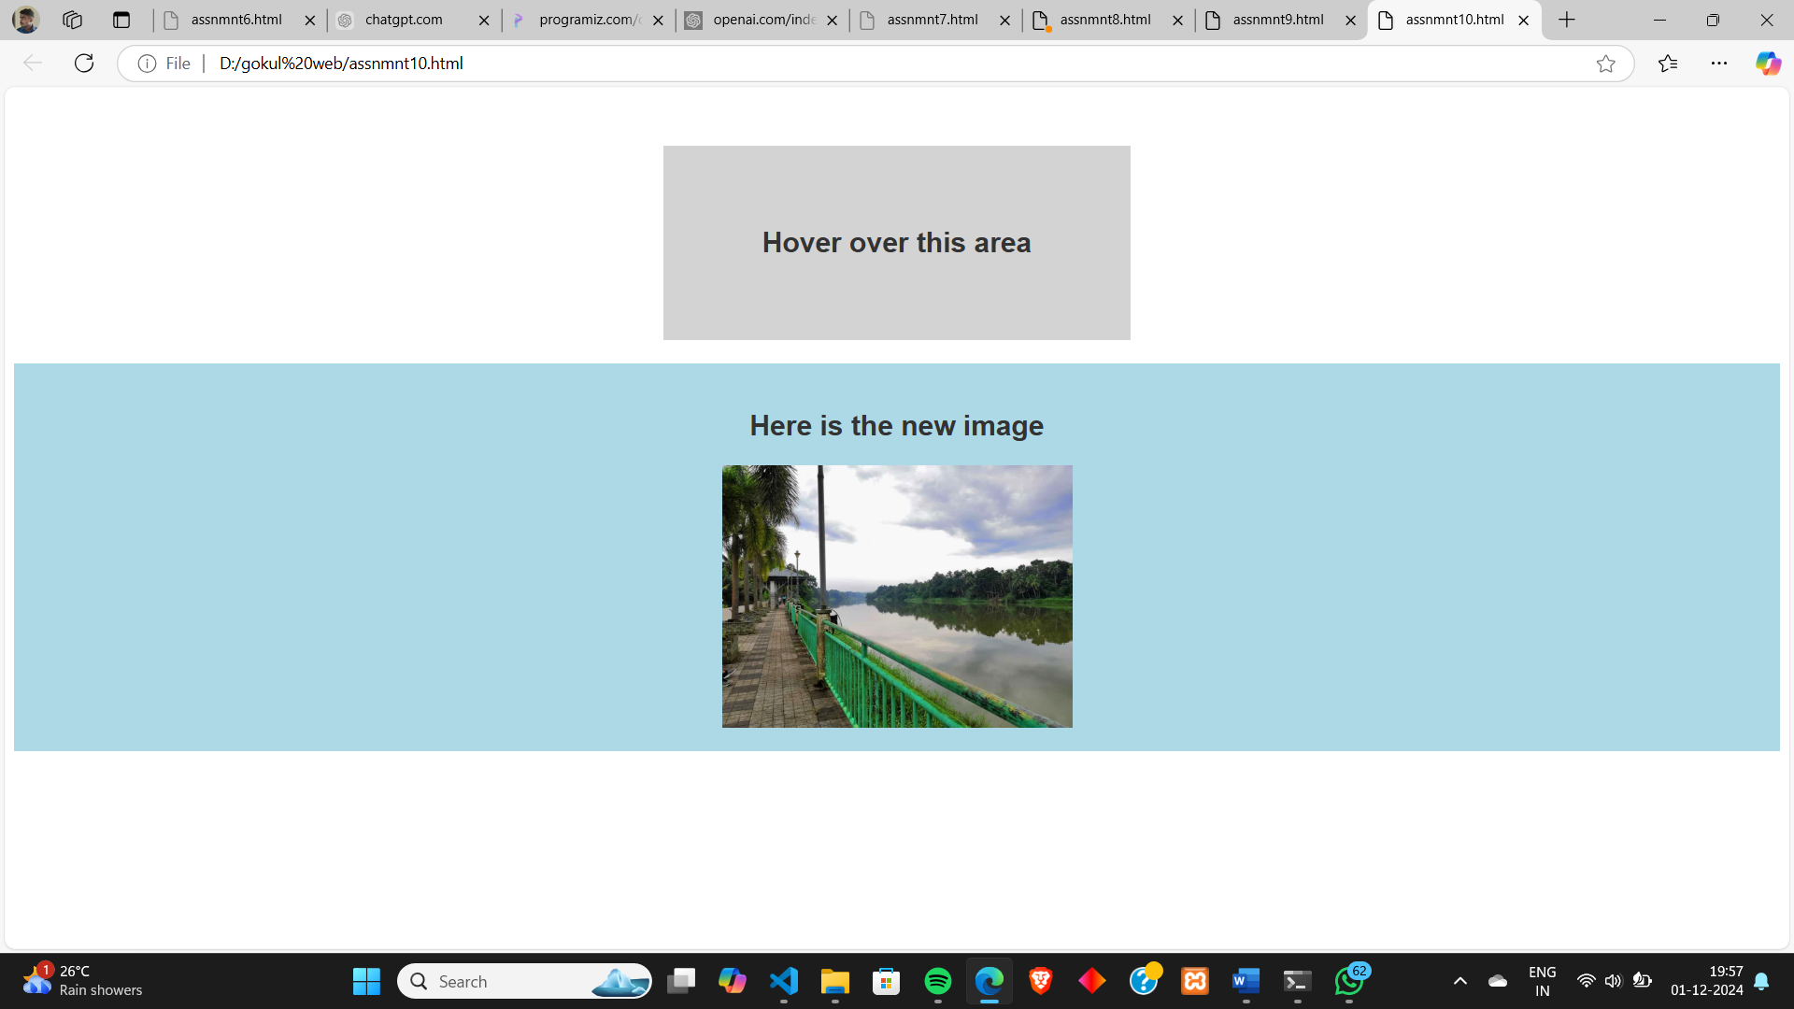

**Program # 11**

Create a HTML registration form and to validate the form using JavaScript code.

**PROGRAM CODE:**

**formvalidation.html**

<html><head> <style> body { font-family: Arial, sans-serif; background-color: #f4f4f4; margin: 0; padding: 0; display: flex; justify-content: center; align-items: center; height: 100vh; } .form-container { background-color: #fff; padding: 20px; border-radius: 8px; box-shadow: 0 4px 8px rgba(0, 0, 0, 0.1); width: 400px; } h2 { text-align: center; color: #333; } label { display: block; margin-bottom: 8px; font-weight: bold; } input, select { width: 95%; padding: 10px; margin-bottom: 10px; border: 1px solid #ccc; border-radius: 4px; } .error { color: red; font-size: 14px; margin-bottom: 10px; }

.success { color: green; font-size: 14px; } button { width: 100%; padding: 10px; background-color: #28a1f8; color: white; border: none; border-radius: 4px; font-size: 16px; } </style></head><body><div class="form-container"> <h2>REGISTRATION FORM</h2> <form id="registrationForm" onsubmit="return validateForm()"> <label for="fname">First Name:</label> <input type="text" id="fname" name="fname" placeholder="Enter first name" > <div id="ferror" class="error"></div> <label for="lname">Last Name</label> <input type="text" id="lname" name="lname" placeholder="Enter last name" > <div id="lerror" class="error"></div> <label for="email">Email</label> <input type="email" id="email" name="email" placeholder="Enter email"> <div id="eerror" class="error"></div> <label for="phone">Phone</label> <input type="text" id="phone" name="phone" placeholder="Enter phone number"> <div id="perror" class="error"></div> <label for="gender">Gender</label> <select id="gender" name="gender"> <option value="">Select Gender</option> <option value="male">Male</option> <option value="female">Female</option> <option value="other">Other</option> </select> <div id="gerror" class="error"></div> <label for="password">Password</label> <input type="password" id="password" name="password" placeholder="Enter password"> <div id="passerror" class="error"></div> <label for="cPassword">Confirm Password</label> <input type="password" id="cPassword" name="cPassword" placeholder="Confirm password"> <div id="cperror" class="error"></div> <button type="submit">Register</button> </form> <div id="formSuccess" class="success"></div></div><script> function validateForm() { let isValid = true; document.getElementById("ferror").innerHTML = ""; document.getElementById("lerror").innerHTML = ""; document.getElementById("eerror").innerHTML = ""; document.getElementById("perror").innerHTML = ""; document.getElementById("gerror").innerHTML = ""; document.getElementById("passerror").innerHTML = ""; document.getElementById("cperror").innerHTML = ""; document.getElementById("formSuccess").innerHTML = ""; const fname = document.getElementById("fname").value; const lname = document.getElementById("lname").value; const email = document.getElementById("email").value; const phone = document.getElementById("phone").value; const gender = document.getElementById("gender").value; const password = document.getElementById("password").value; const confirmPassword = document.getElementById("cPassword").value; const fnamePattern = /^[A-Za-z]+$/; if (fname === "") { document.getElementById("ferror").innerHTML = "Please enter valid first Name."; isValid = false; } else if (!fnamePattern.test(fname)) { document.getElementById("ferror").innerHTML = "Enter Valid Name."; isValid = false; } const lnamePattern = /^[A-Za-z\s\-']+$/; if (lname === "") { document.getElementById("lerror").innerHTML = "Please enter valid second Name."; isValid = false; } else if (!lnamePattern.test(lname)) { document.getElementById("lerror").innerHTML = "Enter Valid Name."; isValid = false; } const emailPattern = /^[a-zA-Z0-9._-]+@[a-zA-Z0-9.-]+\.[a-zA-Z]{2,6}$/; if (email === "" || !emailPattern.test(email)) {

document.getElementById("eerror").innerHTML = "Please enter a valid email address."; isValid = false; } const phonePattern = /^[0-9]{10}$/; if (phone === "" || !phonePattern.test(phone)) { document.getElementById("perror").innerHTML = "Please enter a valid 10-digit phone number."; isValid = false; } if (gender === "") { document.getElementById("gerror").innerHTML = "Gender is required."; isValid = false; } if (password === "") { document.getElementById("passerror").innerHTML = "Password is required."; isValid = false; } else if (password.length < 6) { document.getElementById("passerror").innerHTML = "Password must be at least 6 characters."; isValid = false; } if (confirmPassword !== password) { document.getElementById("cperror").innerHTML = "Passwords do not match."; isValid = false; } if (isValid) { alert("Registration Successfull"); } return isValid; }</script></body></html>

**OUTPUT:**

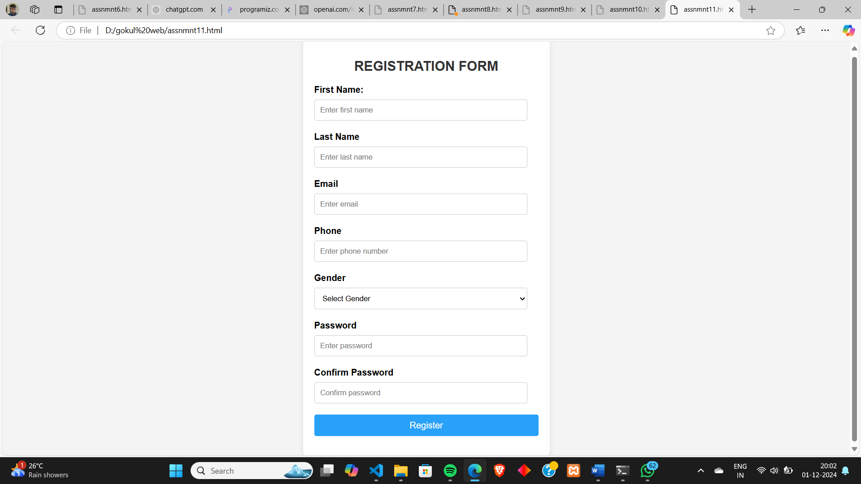

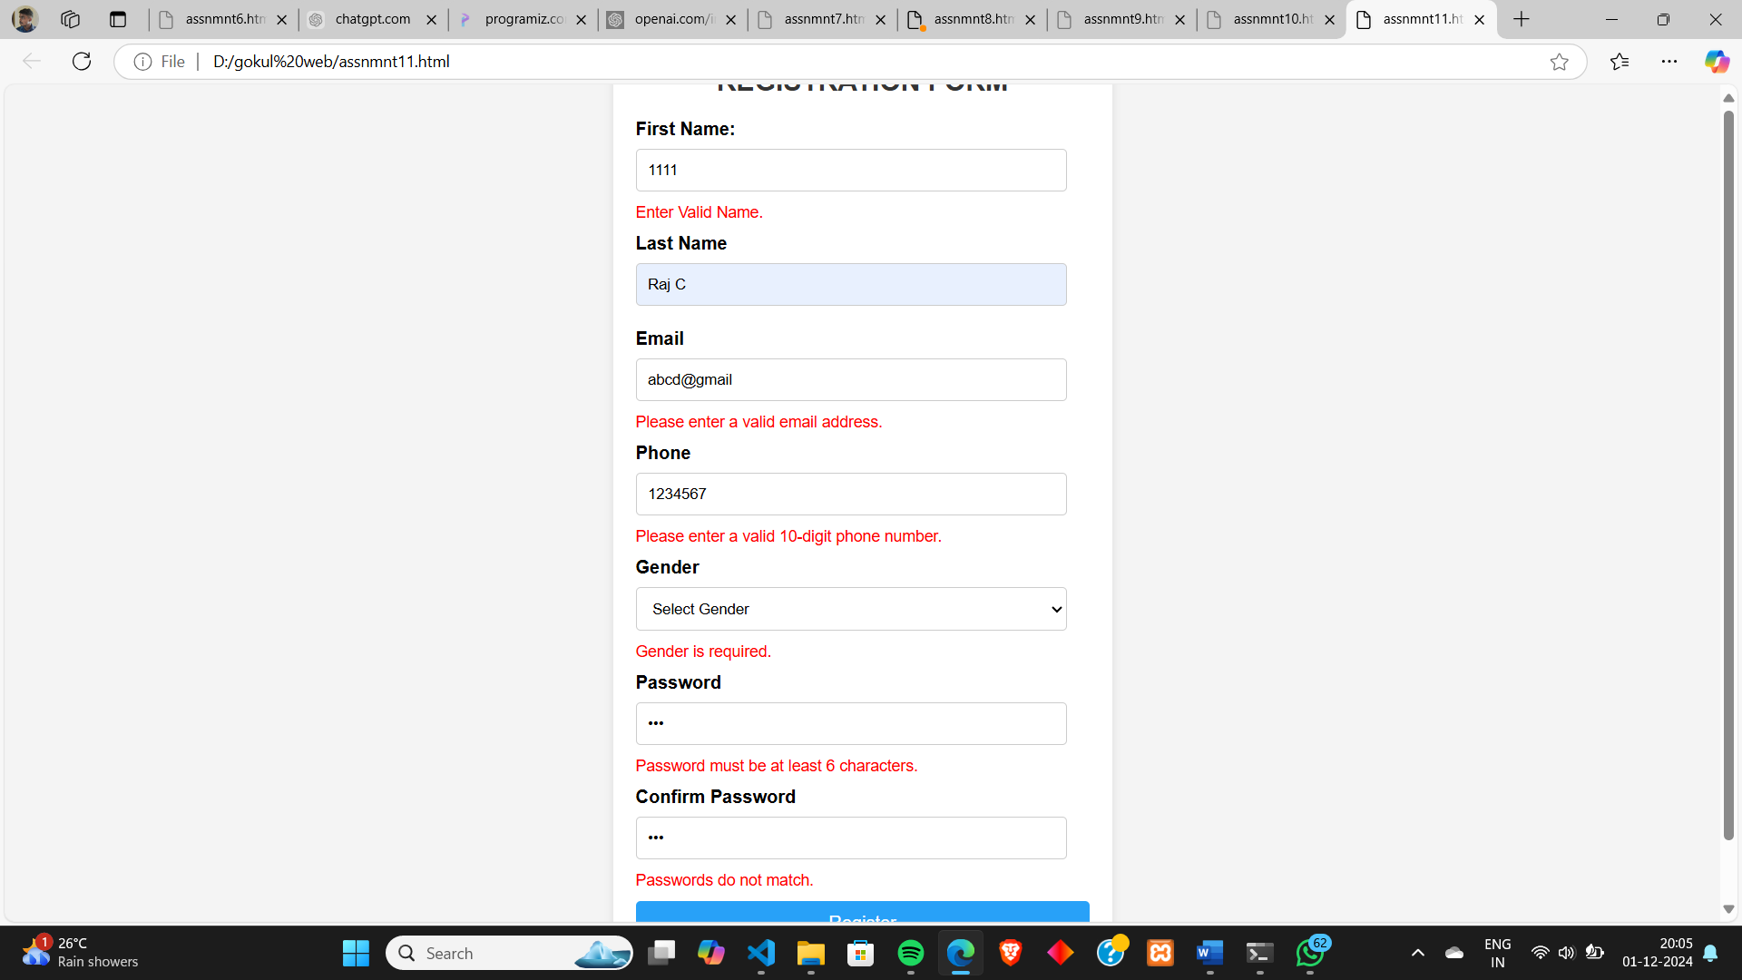

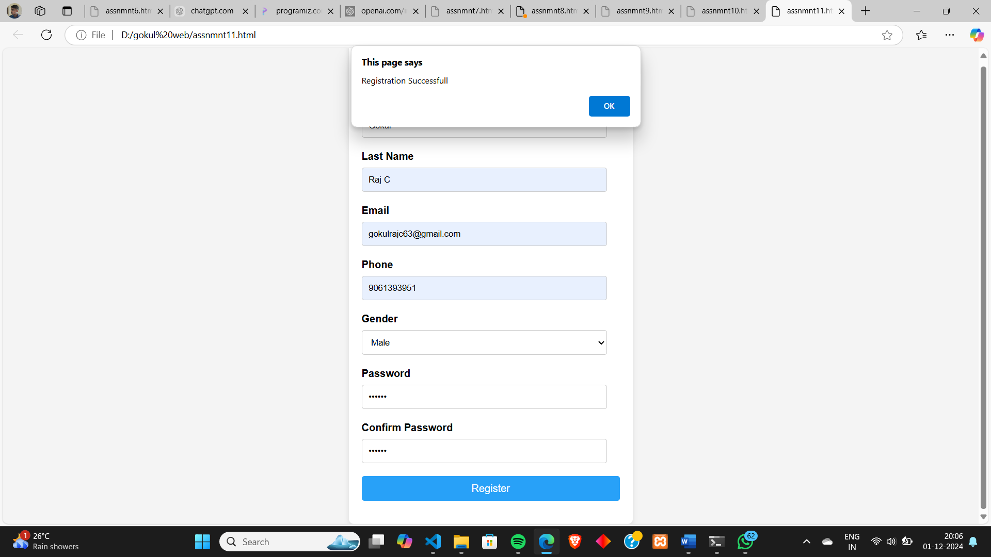

**Program # 12**

Design and develop a complete Online exam using Html, CSS and JavaScript.

**PROGRAM CODE:**

**onlineexam.html**

<html><head> <style> body { font-family: Arial, sans-serif; background-color: #f4f4f4; margin: 0; padding: 0; } .exam-container { width: 50%; margin: 50px auto; padding: 20px; background-color: white; box-shadow: 0 4px 8px rgba(0, 0, 0, 0.1); border-radius: 8px; } h1 { text-align: center; color: #333; } .question { margin-bottom: 20px; } .question h3 { font-size: 18px; margin-bottom: 10px; } .answer { margin: 10px 0; } .answer input { margin-right: 10px; } .submit-btn { display: block; width: 100%; padding: 10px; background-color: #28a1f8; color: white;

font-size: 16px; border: none; cursor: pointer; border-radius: 5px; } </style></head><body><div class="exam-container"> <h1>ONLINE TEST</h1> <form id="examForm" onsubmit="return calculateResults(event)"> <div class="question"> <h3>1. Which of the following is used to style web pages?Which of the following is used to style web pages?</h3> <div class="answer"> <input type="radio" name="q1" value="html" id="q1a1"> HTML </div> <div class="answer"> <input type="radio" name="q1" value="css" id="q1a2"> CSS </div> <div class="answer"> <input type="radio" name="q1" value="javascript" id="q1a3"> JavaScript </div> <div class="answer"> <input type="radio" name="q1" value="sql" id="q1a4"> SQL </div> </div> <div class="question"> <h3>2. Which of the following is an example of a non-volatile memory?</h3> <div class="answer"> <input type="radio" name="q2" value="ram" id="q2a1"> RAM </div> <div class="answer"> <input type="radio" name="q2" value="cache" id="q2a2"> Cache </div> <div class="answer"> <input type="radio" name="q2" value="rom" id="q2a3"> ROM </div> <div class="answer"> <input type="radio" name="q2" value="register" id="q2a4"> Register </div> </div> <div class="question"> <h3>3. Which data structure uses LIFO (Last In First Out) principle?</h3> <div class="answer"> <input type="radio" name="q3" value="linkedlist" id="q3a1"> Linked List </div> <div class="answer"> <input type="radio" name="q3" value="queue" id="q3a2"> Queue

</div> <div class="answer"> <input type="radio" name="q3" value="stack" id="q3a3"> Stack </div> <div class="answer"> <input type="radio" name="q3" value="array" id="q3a4"> Array </div> </div> <div class="question"> <h3>4. What is the full form of the acronym 'URL'?</h3> <div class="answer"> <input type="radio" name="q4" value="uniloc" id="q4a1"> Uniform Resource Locator </div> <div class="answer"> <input type="radio" name="q4" value="univerloc" id="q4a2"> Universal Resource Locator </div> <div class="answer"> <input type="radio" name="q4" value="unilink" id="q4a3"> Uniform Resource Link </div> <div class="answer"> <input type="radio" name="q4" value="univerlink" id="q4a4"> Universal Resource Link </div> </div> <div class="question"> <h3>5. WWhich of the following is the largest unit of storage?</h3> <div class="answer"> <input type="radio" name="q5" value="kilo" id="q5a1"> Kilobyte </div> <div class="answer"> <input type="radio" name="q5" value="tera" id="q5a2"> Terabyte </div> <div class="answer"> <input type="radio" name="q5" value="mega" id="q5a3"> Megabyte </div> <div class="answer"> <input type="radio" name="q5" value="giga" id="q5a4"> Gigabyte </div> </div> <button type="submit" class="submit-btn">Submit Exam</button> </form> <div id="result" class="result"></div></div><script>

function calculateResults(event) { event.preventDefault(); let answ1="css"; let answ2="rom"; let answ3="stack"; let answ4="uniloc"; let answ5="tera"; let score = 0; let que1 = document.querySelector('input[name="q1"]:checked').value; let que2 = document.querySelector('input[name="q2"]:checked').value; let que3 = document.querySelector('input[name="q3"]:checked').value; let que4 = document.querySelector('input[name="q4"]:checked').value; let que5 = document.querySelector('input[name="q5"]:checked').value; if (que1==answ1) { score++; } if (que2==answ2) { score++; } if (que3==answ3) { score++; } if (que4==answ4) { score++; } if (que5==answ5) { score++; } let resultMessage = `You scored ${score} out of 5.`;alert(resultMessage); }</script></body></html>

**OUTPUT:**

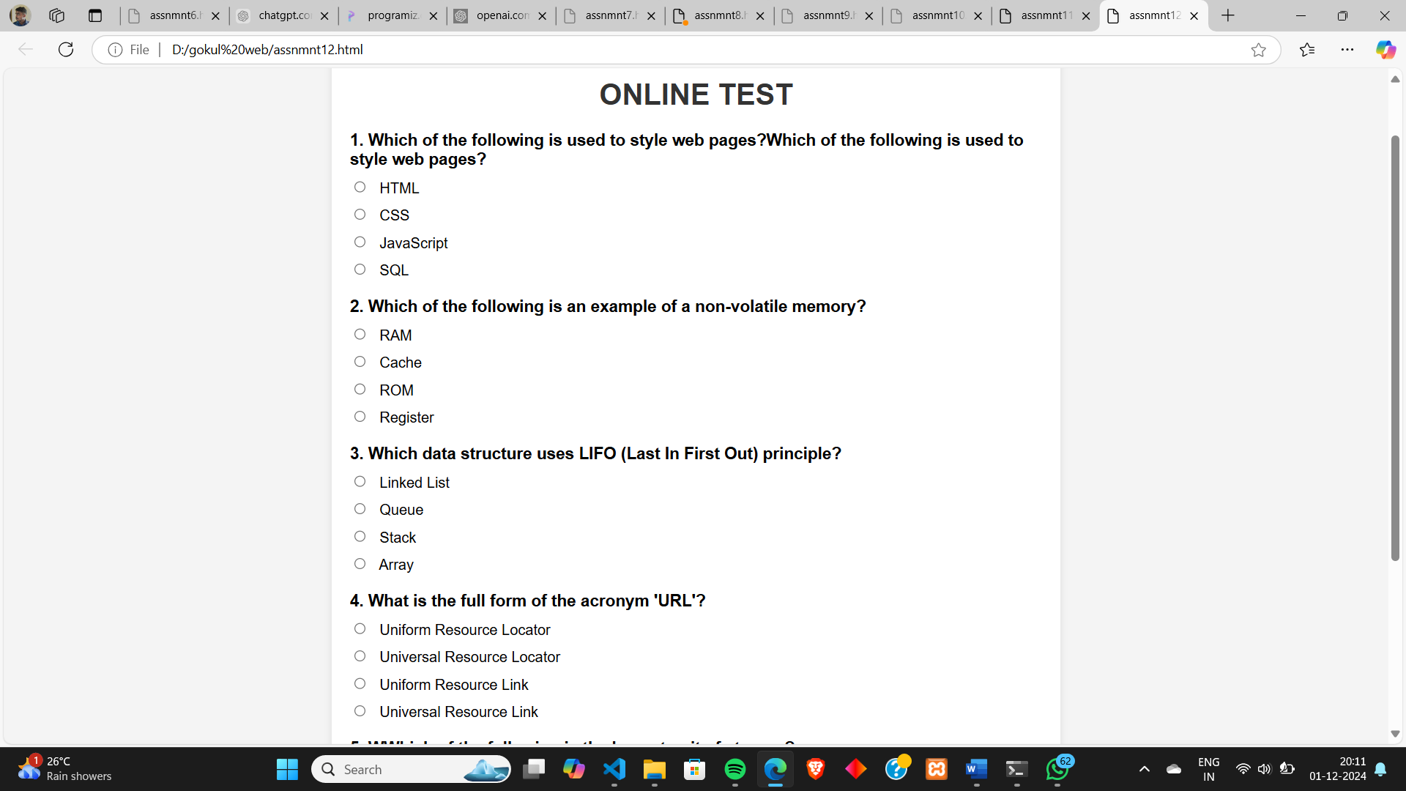

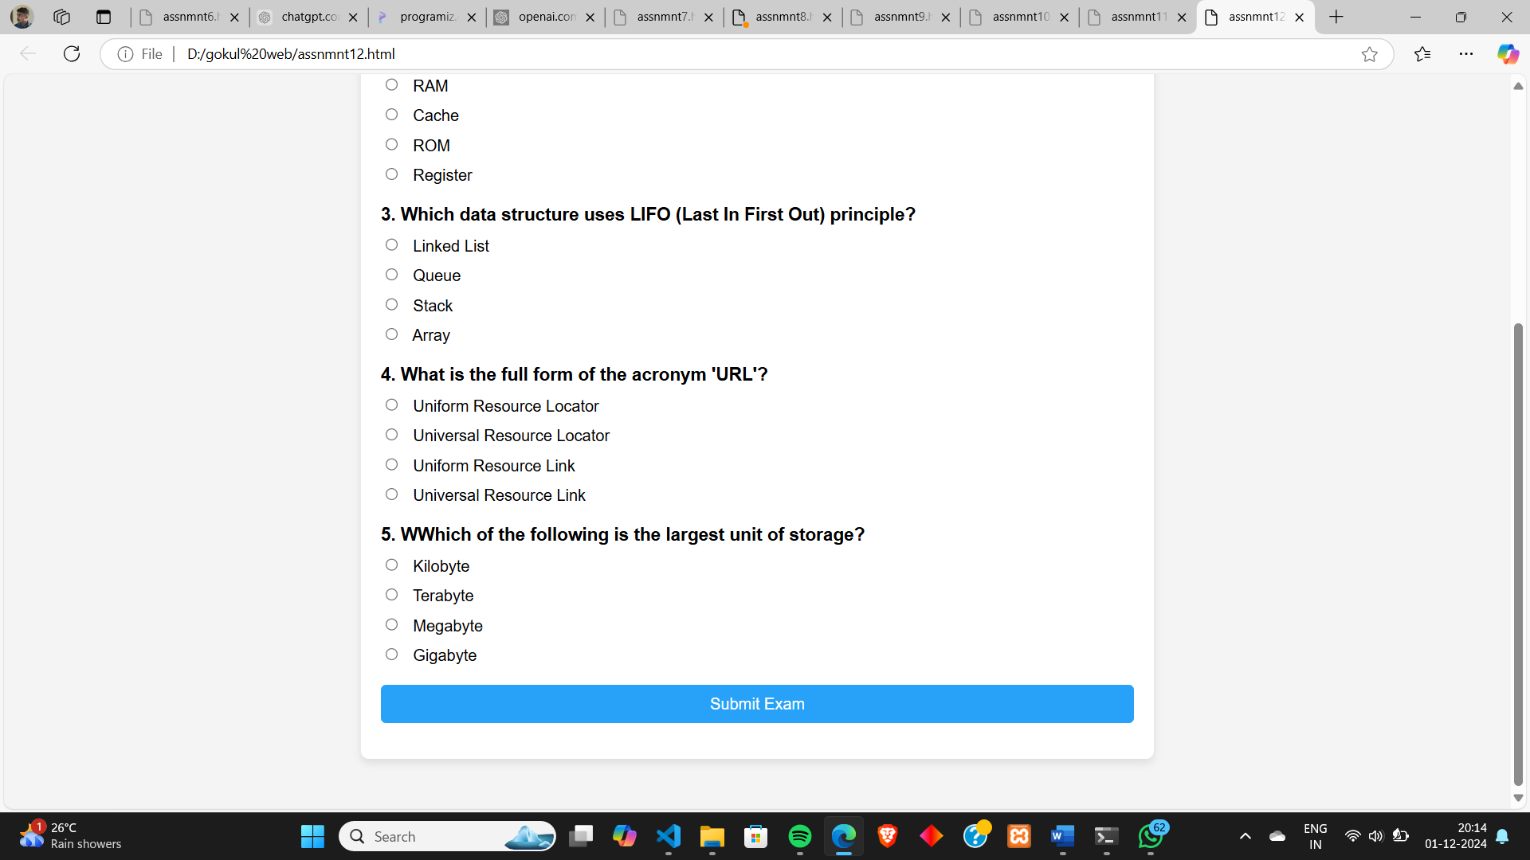

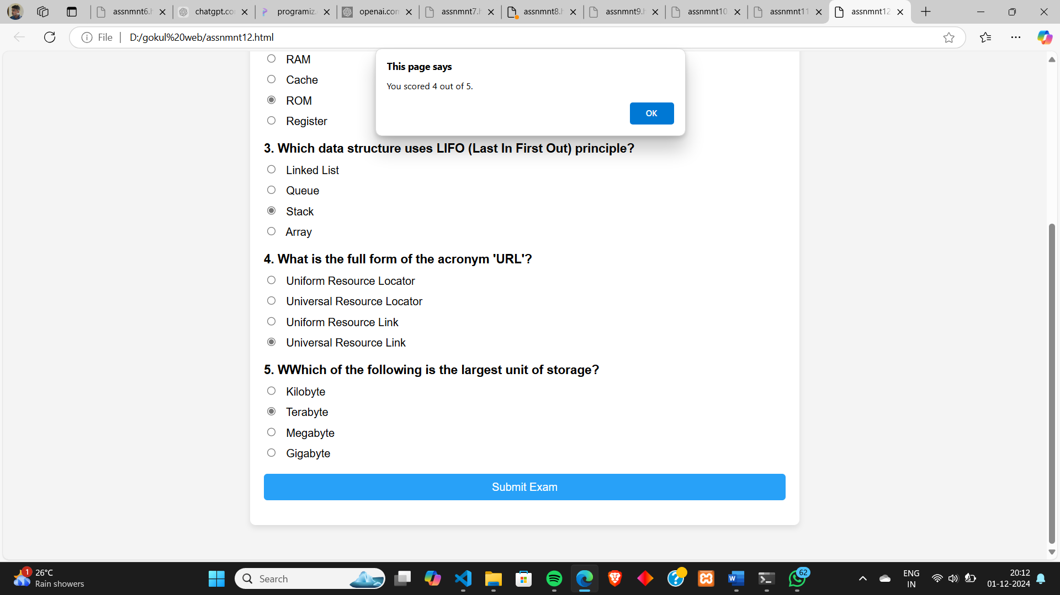

**Lab Cycle 3**

**CO3: Do Client-side & Server-side scripting**

**Program # 13**

Build a PHP code to store name of students in an array and display it using print_r function. Sort and display the same using asort & arsort functions.

**PROGRAM CODE:**

**arrayfunctions.php**

<?php

$students=array("101"=>"Gokul","102"=>"Abhijith","103"=>"Ashitha","104"=>"Gopika");

echo "Orginal Array";

echo "<br>";

print_r($students);

asort($students);

echo "<br><br>";

echo "Array after asort";

echo "<br>";

print_r($students);

arsort($students);

echo "<br><br>";

echo "Array after arsort";

echo "<br>";

print_r($students);

**OUTPUT:**

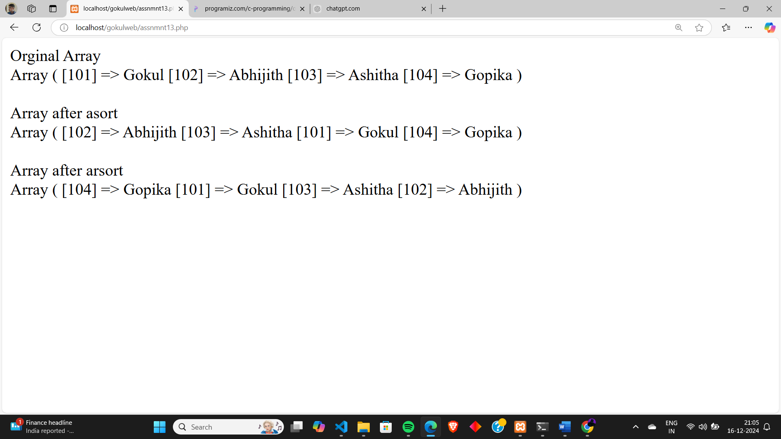

**Program # 14**

Build a PHP code to store name of Indian Cricket players in an array and display the same in HTML table.

**PROGRAM CODE:**

**playerdetails.php**

<html>

<head>

<style>

table, th, td

{

  border: 3px solid black;

  border-collapse: collapse;

}

td {

  height: 40px;

  padding: 10px;

}

th {

  height: 40px;

  padding: 10px;

}

</style>

</head>

<body>

<h2>Cricket Players</h2>

<?php

$players = array("Virat Kohli","Rohit Sharma","MS Dhoni","Shikhar Dhawan","KL Rahul","Jasprit Bumrah",

"Ravindra Jadeja","Hardik Pandya","Ravichandran Ashwin","Shreyas Iyer");

?>

<table style="width:30%">

<tr><th>Player Names</th></tr>

<?php

foreach ($players as $x) {

    echo "<tr><td>$x</td></tr>";}

?>

</table>

</body>

</html>

**OUTPUT:**

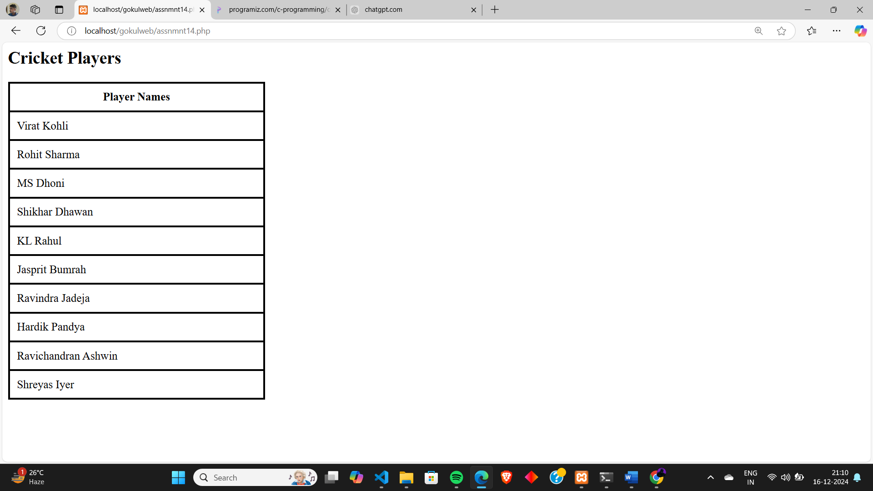

**Program # 15**

Design a registration form in HTML, and do necessary validations using PHP

**PROGRAM CODE:**

**formvalidation.php**

<html>

<head>

    <style>

        body {

            font-family: Arial, sans-serif;

            background-color: #f4f4f4;

            margin: 0;

            padding: 0;

            display: flex;

            justify-content: center;

            align-items: center;

            height: 100vh;

        }

        .form-container {

            background-color: #fff;

            padding: 20px;

            border-radius: 8px;

            box-shadow: 0 4px 8px rgba(0, 0, 0, 0.1);

            width: 400px;

        }

        h2 {

            text-align: center;

            color: #333;

        }

        label {

            display: block;

            margin-bottom: 8px;

            font-weight: bold;

        }

        input, select {

            width: 95%;

            padding: 10px;

            margin-bottom: 10px;

            border: 1px solid #ccc;

            border-radius: 4px;

}

        .error {

            color: red;

            font-size: 14px;

            margin-bottom: 10px;

        }

        .success {

            color: green;

            font-size: 14px;

        }

        button {

            width: 100%;

            padding: 10px;

            background-color: #28a1f8;

            color: white;

            border: none;

            border-radius: 4px;

            font-size: 16px;

        }

    </style>

</head>

<body>

<?php

$fnameErr=$lnameErr=$emailErr=$phoneErr=$genderErr=$passwErr=$cpasswErr="";

$fname=$lname=$email=$phone=$gender=$passw=$cpassw="";

$registrationSuccess = false;

if($_SERVER["REQUEST_METHOD"]=="POST")

{

$fname=$_POST["fname"];

$lname=$_POST["lname"];

$email=$_POST["email"];

$phone=$_POST["phone"];

$gender=$_POST["gender"];

$passw=$_POST["password"];

$cpassw=$_POST["cpassword"];

if ($fname === "")

{

$fnameErr = "Fisrt Name required";

}

else if (!preg_match("/^[A-Za-z]+$/", $fname))

{

$fnameErr = "Only letters are allowed";

}

if ($lname === "")

{

$lnameErr = "Last Name required";

}

else if (!preg_match("/^[A-Za-z\s\-']+$/", $lname))

{

$lnameErr = "Only letters are allowed";

}

if ($email === "")

{

$emailErr = "Email required";

}

else if (!preg_match("/^[a-zA-Z0-9._-]+@[a-zA-Z0-9.-]+\.[a-zA-Z]{2,6}$/", $email))

{

$emailErr = "Enter Valid Email";

}

if ($phone === "")

{

$phoneErr = "Phone Number required";

}

else if (!preg_match("/^[0-9]{10}$/", $phone))

{

$phoneErr = "Enter Valid Number";

}

if ($gender === "")

{

$genderErr = "Gender required";

}

if ($passw === "")

{

$passwErr = "Password required";

}

else if (strlen($passw) < 6)

{

$passwErr = "Enter Valid Password";

}

if ($cpassw === "")

{

$cpasswErr = "Confirm Password required";

}

else if ($passw!=$cpassw)

{

$cpasswErr = "Password do not Match";

}

if (empty($fnameErr) && empty($lnameErr) && empty($emailErr) && empty($phoneErr) && empty($genderErr) && empty($passwErr) && empty($cpasswErr)) {

    $registrationSuccess = true;

}

}

?>

<div class="form-container">

    <h2>REGISTRATION FORM</h2>

    <form id="registrationForm" method="POST" action="<?php echo $_SERVER['PHP_SELF'];?>">

        <label for="fname">First Name:</label>

        <input type="text" id="fname" name="fname" value="<?php echo $fname;?>" placeholder="Enter first name" >

        <div id="passerror" class="error"><?php echo $fnameErr;?></div>

        <label for="lname">Last Name</label>

        <input type="text" id="lname" name="lname" value="<?php echo $lname;?>" placeholder="Enter last name" >

        <div id="passerror" class="error"><?php echo $lnameErr;?></div>

        <label for="email">Email</label>

        <input type="text" id="email" name="email" value="<?php echo $email;?>" placeholder="Enter email">

        <div id="passerror" class="error"><?php echo $emailErr;?></div>

        <label for="phone">Phone</label>

        <input type="text" id="phone" name="phone" value="<?php echo $phone;?>" placeholder="Enter phone number">

        <div id="passerror" class="error"><?php echo $phoneErr;?></div>

        <label for="gender">Gender</label>

        <select id="gender" name="gender" value="gender">

            <option value="">Select Gender</option>

            <option value="male">Male</option>

            <option value="female">Female</option>

            <option value="other">Other</option>

        </select>

        <div id="passerror" class="error"><?php echo $genderErr;?></div>

        <label for="password">Password</label>

        <input type="password" id="password" name="password" value="<?php echo $passw;?>" placeholder="Enter password">

        <div id="passerror" class="error"><?php echo $passwErr;?></div>

        <label for="cPassword">Confirm Password</label>

        <input type="password" id="cpassword" name="cpassword" value="<?php echo $cpassw;?>" placeholder="Confirm password">

        <div id="passerror" class="error"><?php echo $cpasswErr;?></div>

<button type="submit">Register</button>

    </form>

</div>

<?php

if ($registrationSuccess) {

    echo "<script type='text/javascript'>

            alert('Registration successful!');

          </script>";

}

?>

</body>

</html>

**OUTPUT:**

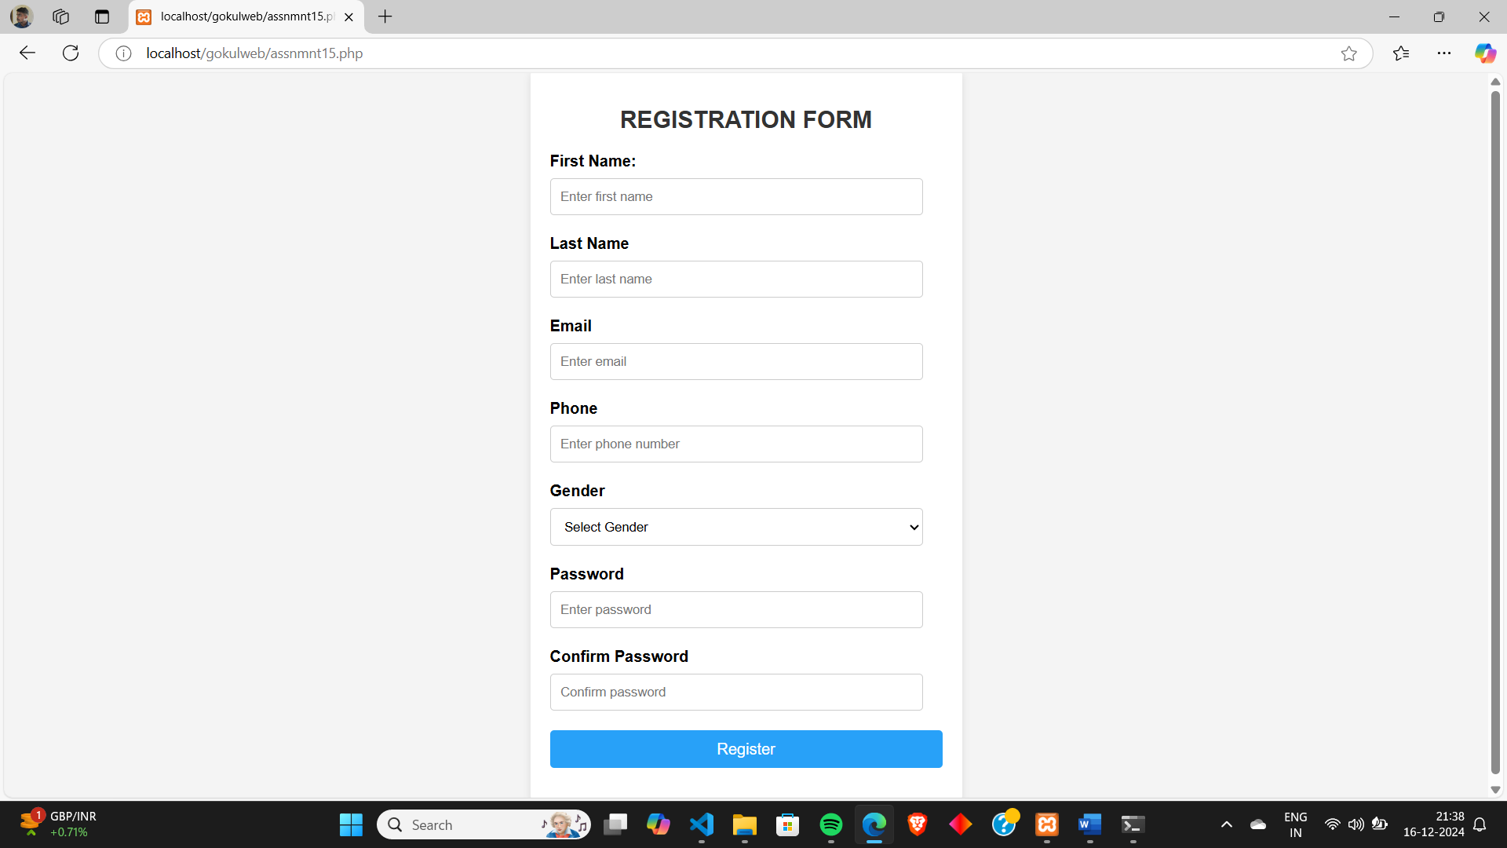

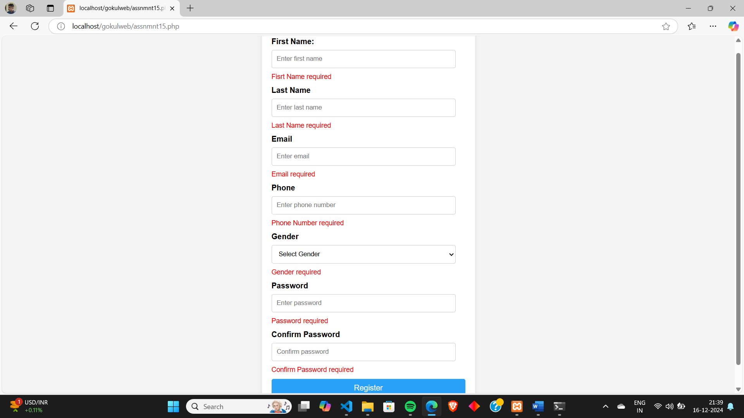

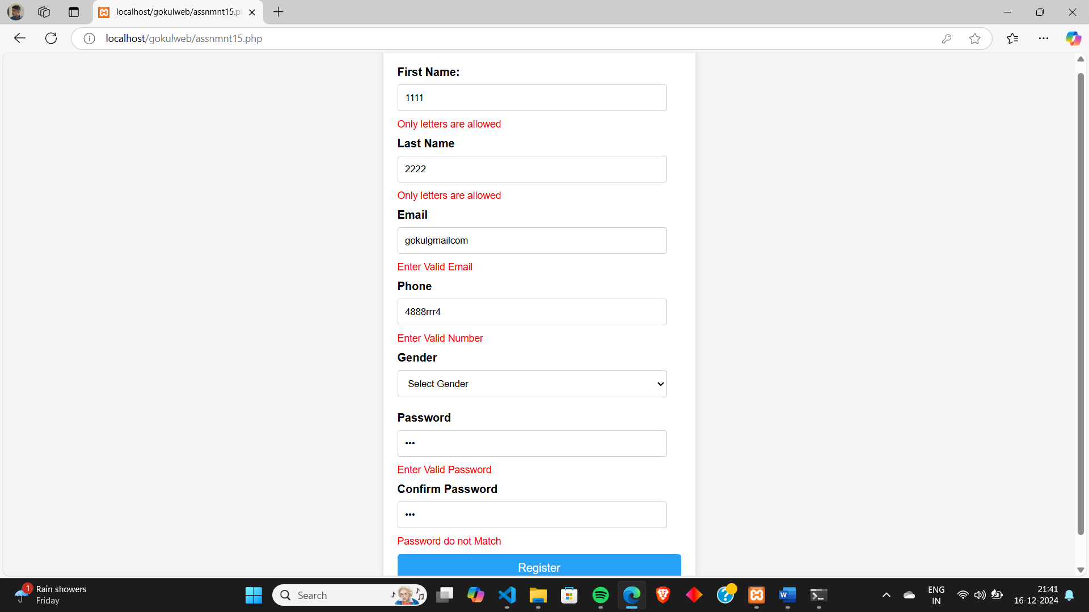

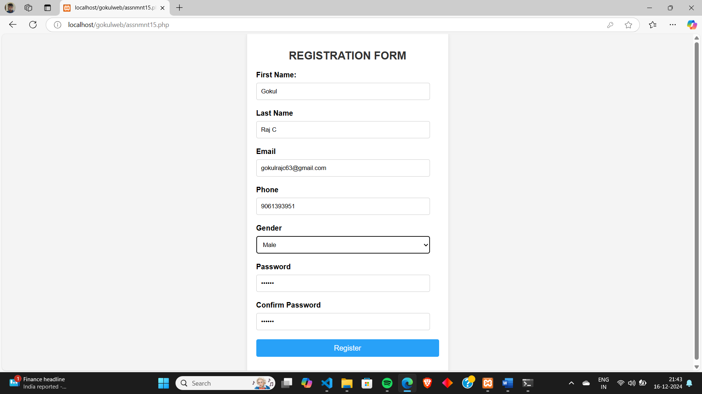

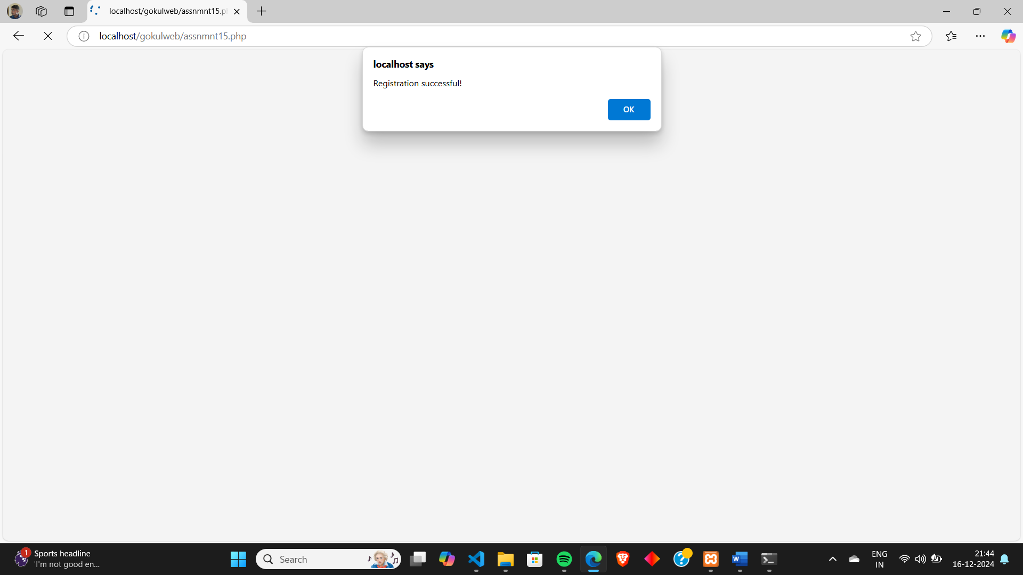

**Program # 16**

Compose Electricity bill from user input based on a given tariff using PHP.

**Tariff:**  
Rate of electricity  for 1-100 units: Rs.5/unit  
Rate of electricity from 101 units  to 200 units: Rs. 7.5/unit  
Rate of electricity from 201 units: Rs.10/unit

**PROGRAM CODE:**

**electricitybill.php**

<html>

<head>

<style>

        body {

            font-family: Arial, sans-serif;

            margin: 0;

            padding: 20px;

            background-color: #f4f4f4;

        }

        h1 {

            text-align: center;

            color: #333;

        }

        .container {

            max-width: 600px;

            margin: 0 auto;

            background-color: #fff;

            padding: 20px;

            border-radius: 10px;

            box-shadow: 0 0 10px rgba(0, 0, 0, 0.1);

        }

        label {

            font-size: 18px;

            margin-bottom: 10px;

            display: block;

        }

        input[type="text"] {

            width: 96%;

            padding: 10px;

            margin: 10px 0 20px 0;

            border: 1px solid #ccc;

            border-radius: 5px;

  font-size: 16px;

        }

        input[type="submit"] {

  width: 100%;

            padding: 10px;

            margin: 10px 0 20px 0;

            border: 1px solid #ccc;

            border-radius: 5px;

            font-size: 16px;

        }

        .error {

            color: red;

            font-size: 14px;

            margin-bottom: 10px;

        }

    </style>

</head>

<body>

<?php

$amount=0;

$valueERR="";

$unit="";

$consumername="";

$consumerno="";

if($_SERVER["REQUEST_METHOD"]=="POST")

{

$unit=$_POST['units'];

$consumerno=$_POST['consumerno'];

$consumername=$_POST['consumername'];

if ($unit=="")

{

$valueERR= "Value Required";

}

else if ($unit<=0)

{

$valueERR= "Value Cannot Be Null Or Zero";

}

else if ($unit<=100)

{

$amount=$unit*5;

}

elseif ($unit<=200)

{

$amount=(100*5)+(($unit-100)*7.5);

}

else

{

$amount=(100*5)+(100*7.5)+(($unit-200)*10);

}

}

?>

<div class="container">

<h1>Electricity Bill</h1>

<form method="POST" action="<?php echo $_SERVER['PHP_SELF'];?>">

<label for="consumerno">Enter Consumer Number:</label>

<input type="text" id="consumerno" name="consumerno" value="<?php echo $consumerno;?>" placeholder="Enter Consumer No">

<label for="consumername">Enter Consumer Name:</label>

<input type="text" id="consumername" name="consumername" value="<?php echo $consumername;?>" placeholder="Enter Consumer Name">

<label for="unit">Enter units consumed:</label>

<input type="text" id="units" name="units" value="<?php echo $unit;?>" placeholder="Enter No Of Units Consumed">

<div id="passerror" class="error"><?php echo $valueERR;?></div>

<input type="submit" name="submit" value="Calculate Bill">

</form>

<div class="result">

<h2>Consumer No: <?php echo $consumerno ?></h2>

<h2>Consumer Name: <?php echo $consumername ?></h2>

<h2>Total Bill: Rs <?php echo $amount ?></h2>

</div>

</div>

</body>

</html>

**OUTPUT:**

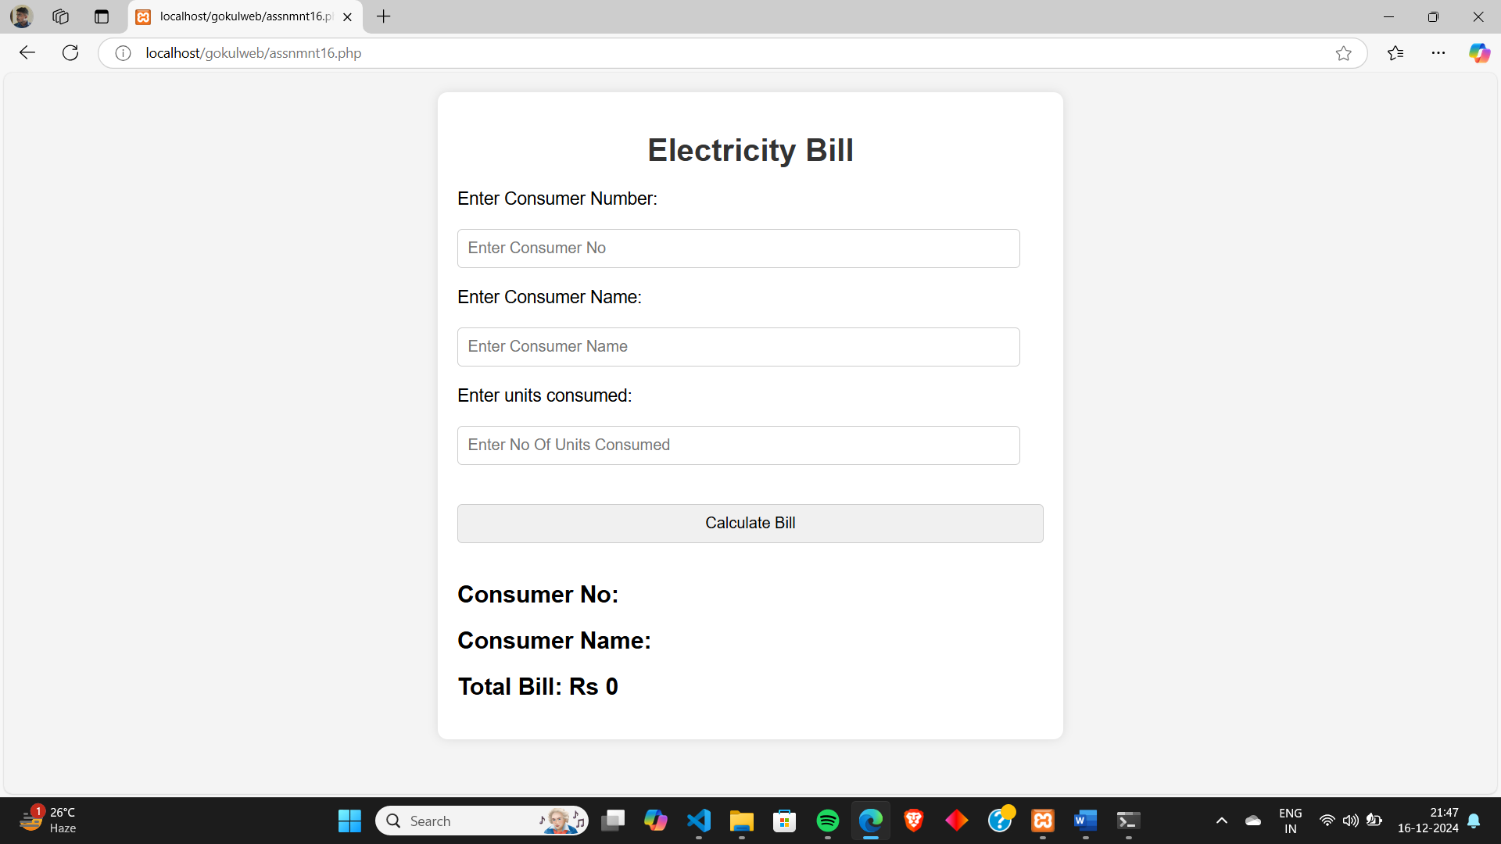

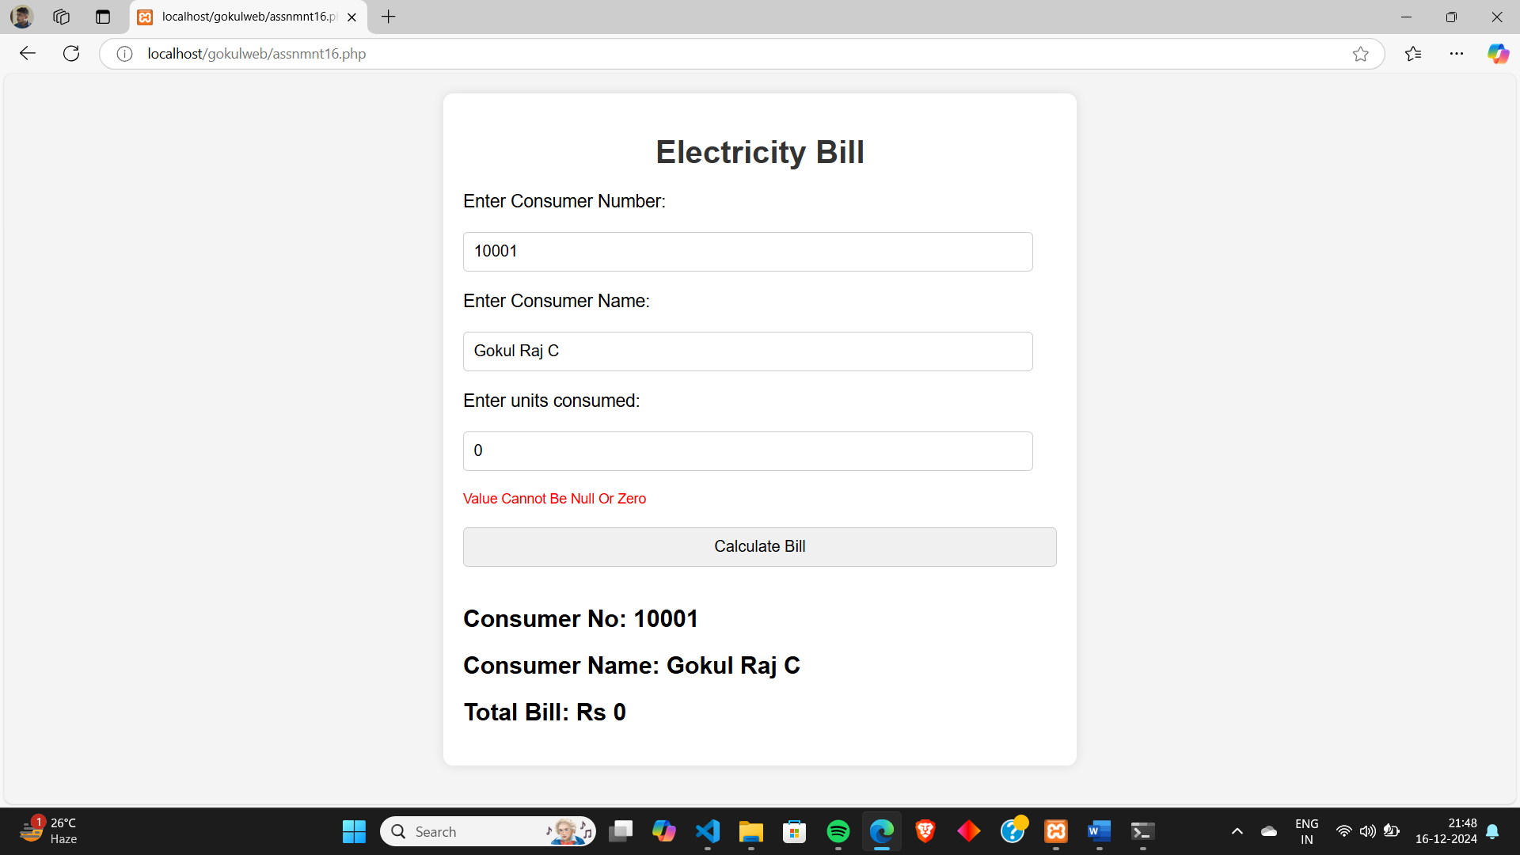

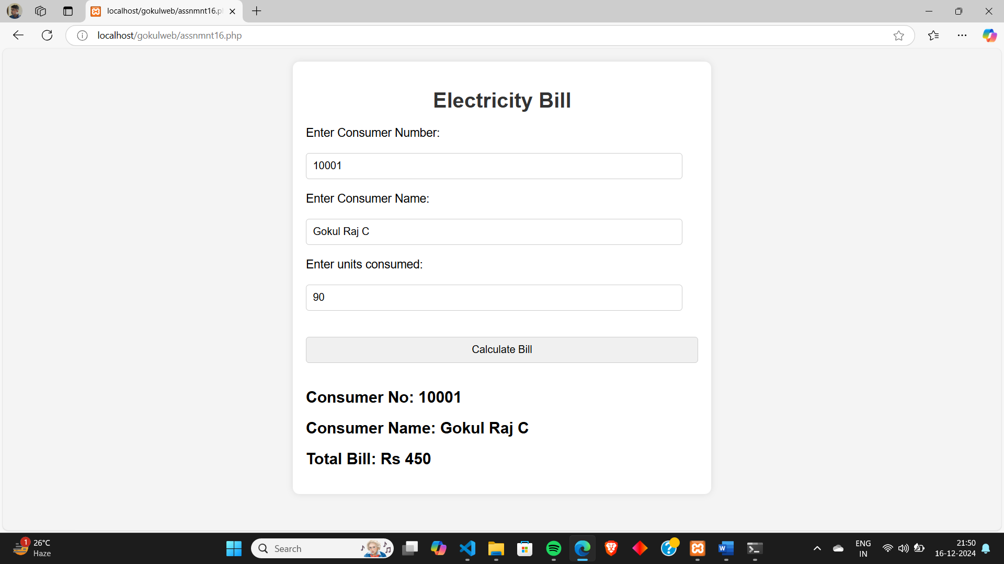

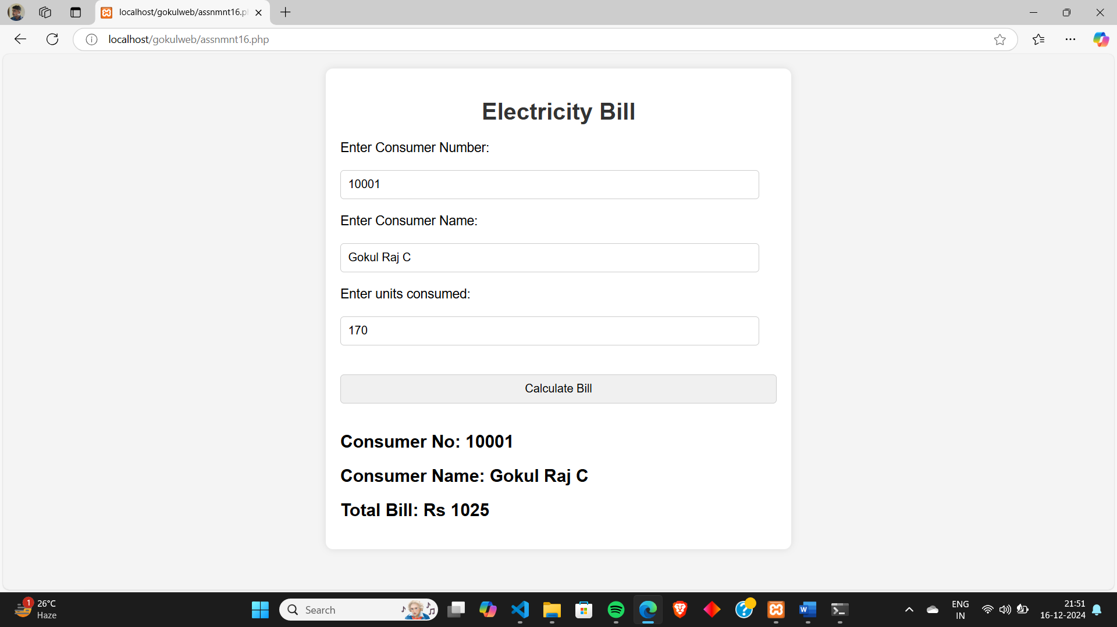

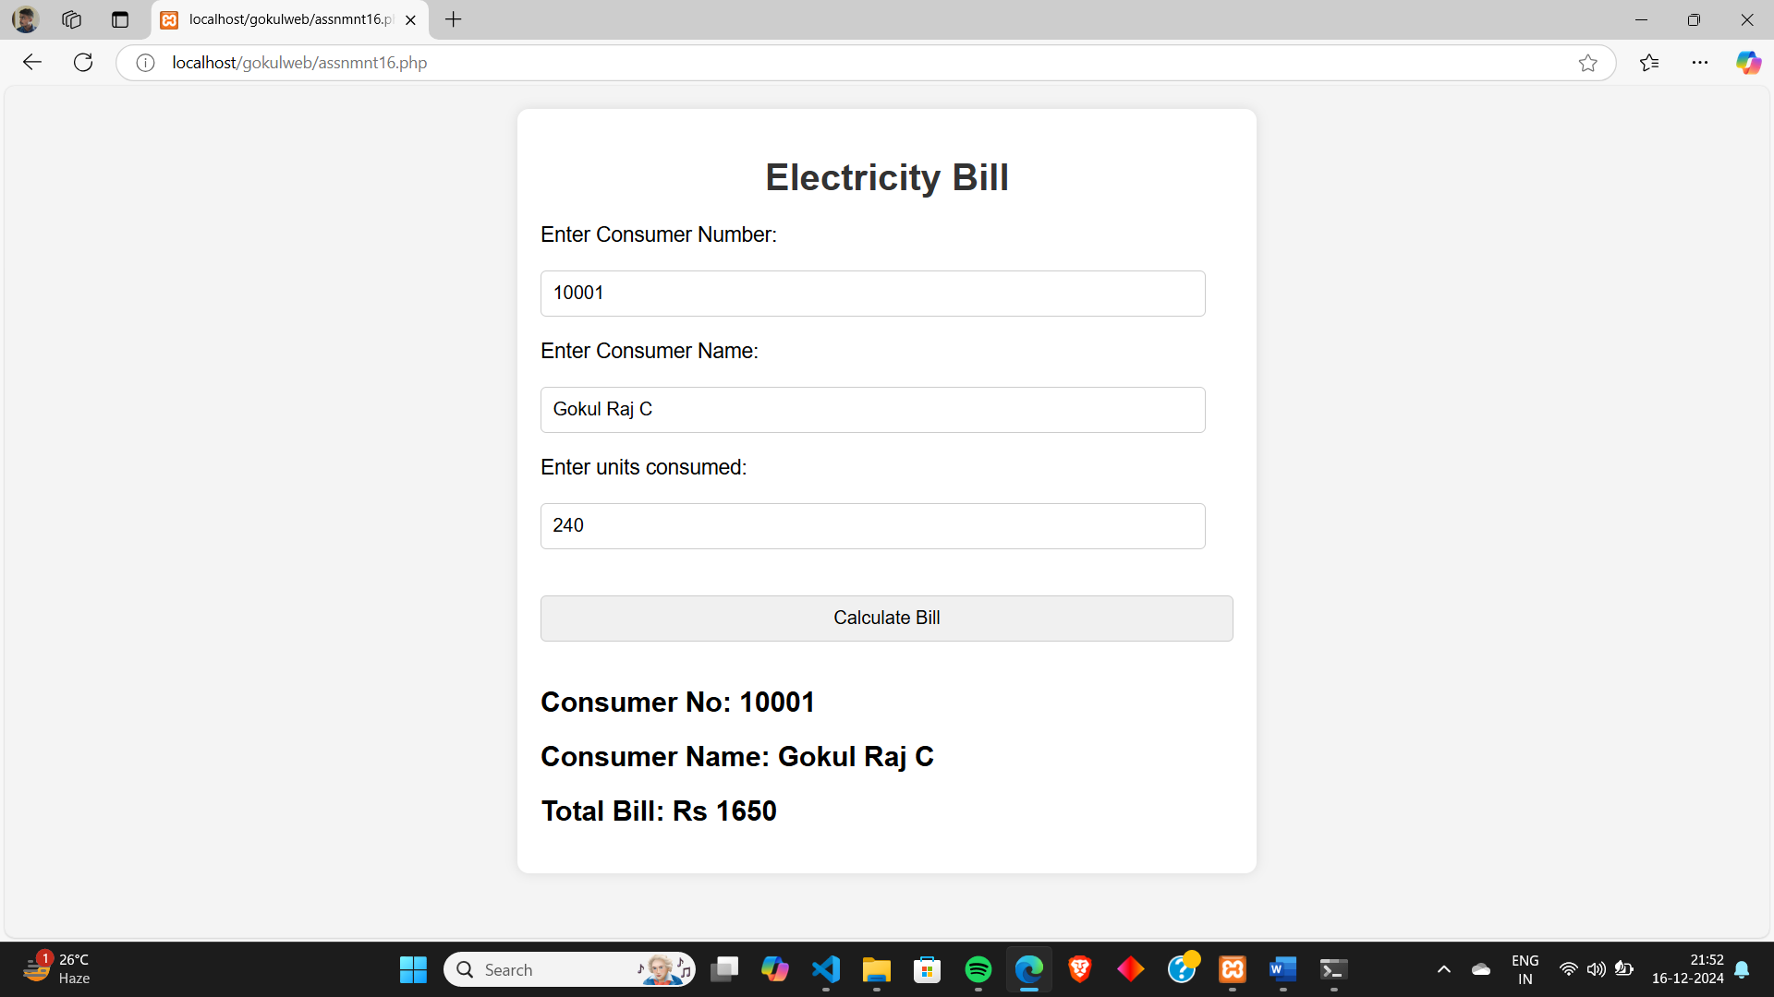

**Lab Cycle 4**

**CO3: Design front end web page and connect to the back-end databases.**

**Program # 17**

Develop a PHP program to connect to a database and retrieve data from a table and show the details in a neat format.

**PROGRAM CODE:**

**table.php**

<html>

<body>

<style>

table, th, td {

  border: 3px solid black;

  border-collapse: collapse;

}

</style>

<body>

<h1>Mark Details</h1>

<?php

$servername="localhost";

$username="root";

$password="";

$dbname="college";

$conn=mysqli_connect($servername,$username,$password,$dbname);

$sql="SELECT * FROM student";

$res=mysqli_query($conn,$sql);

echo '<table style="width:50%">

<tr>

<th><h1>SI No</h1></th>

<th><h1>Roll No</h1></th>

<th><h1>Student Name</h1></th>

<th><h1>DS Mark</h1></th>

<th><h1>ASE Mark</h1></th>

<th><h1>DFCA Mark</h1></th>

<th><h1>MFC Mark</h1></th>

</tr>';

while($row=mysqli_fetch_assoc($res))

{

echo

'<tr>

<th><h1>'.$row["si_no"].'</h1></th>

<th><h1>'.$row["roll_no"].'</h1></th>

<th><h1>'.$row["name"].'</h1></th>

<th><h1>'.$row["ds"].'</h1></th>

<th><h1>'.$row["ase"].'</h1></th>

<th><h1>'.$row["dfca"].'</h1></th>

<th><h1>'.$row["mfc"].'</h1></th>

</tr>';

}

echo '</table>';

?>

</body>

</html>

**Table**

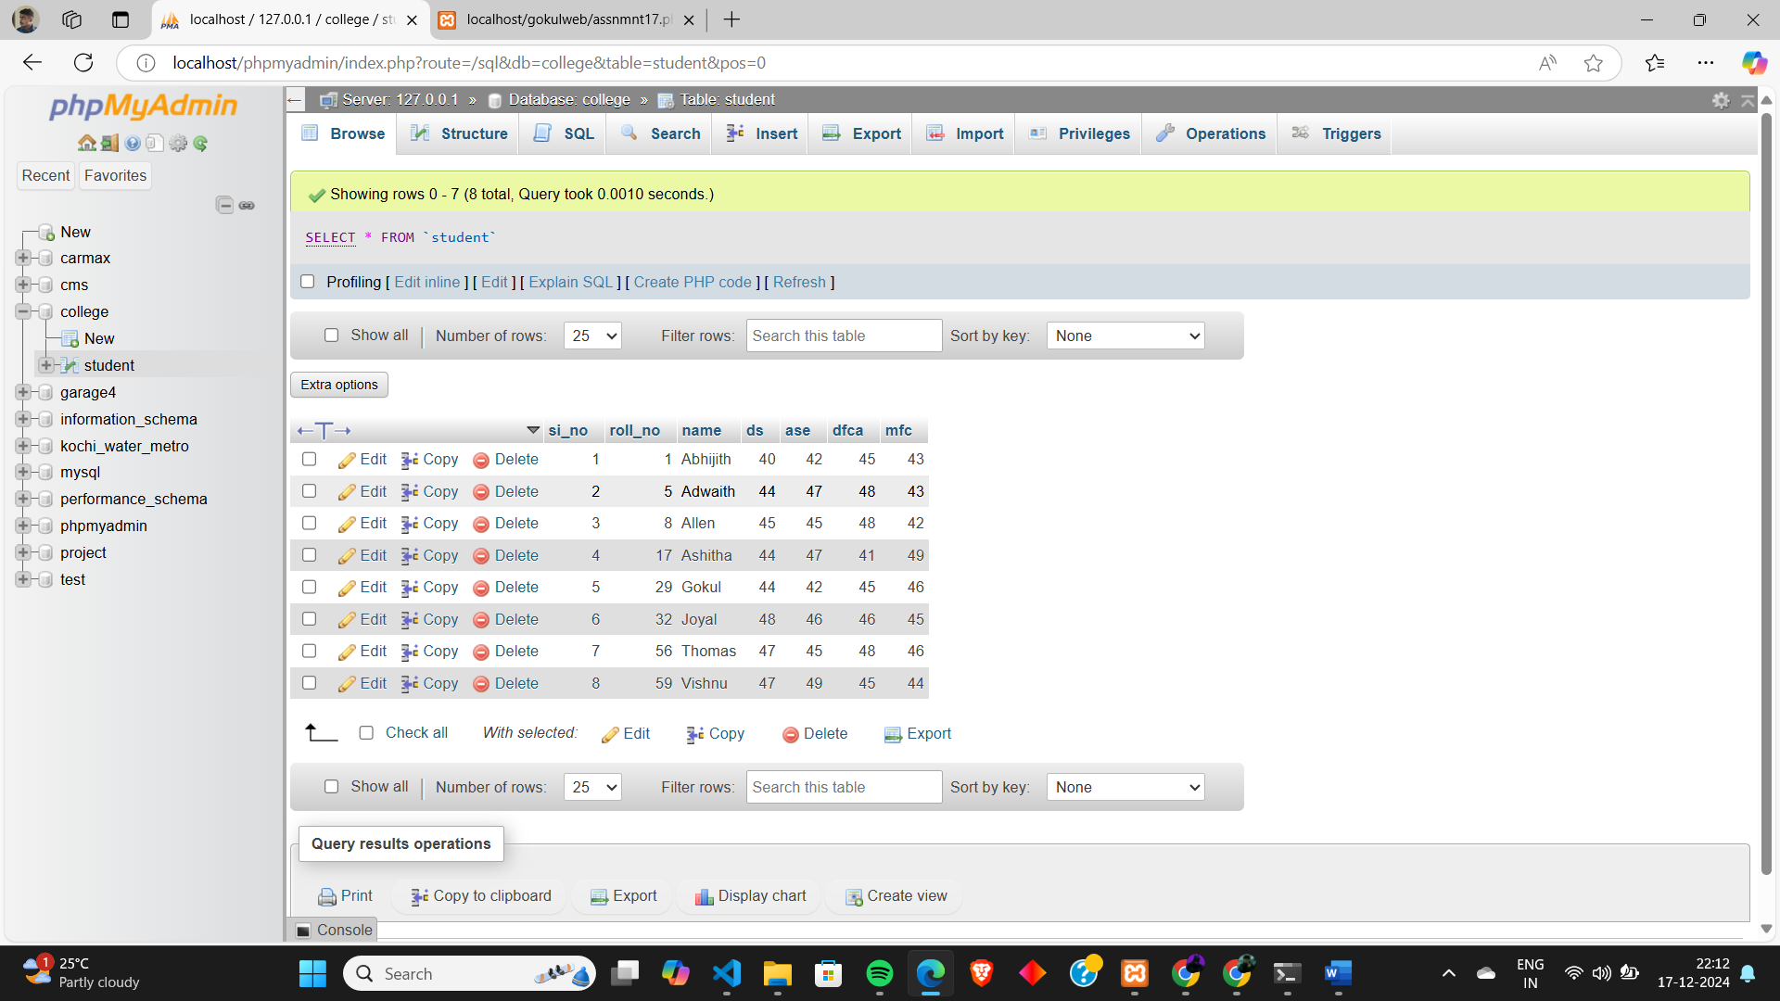

**OUTPUT:**

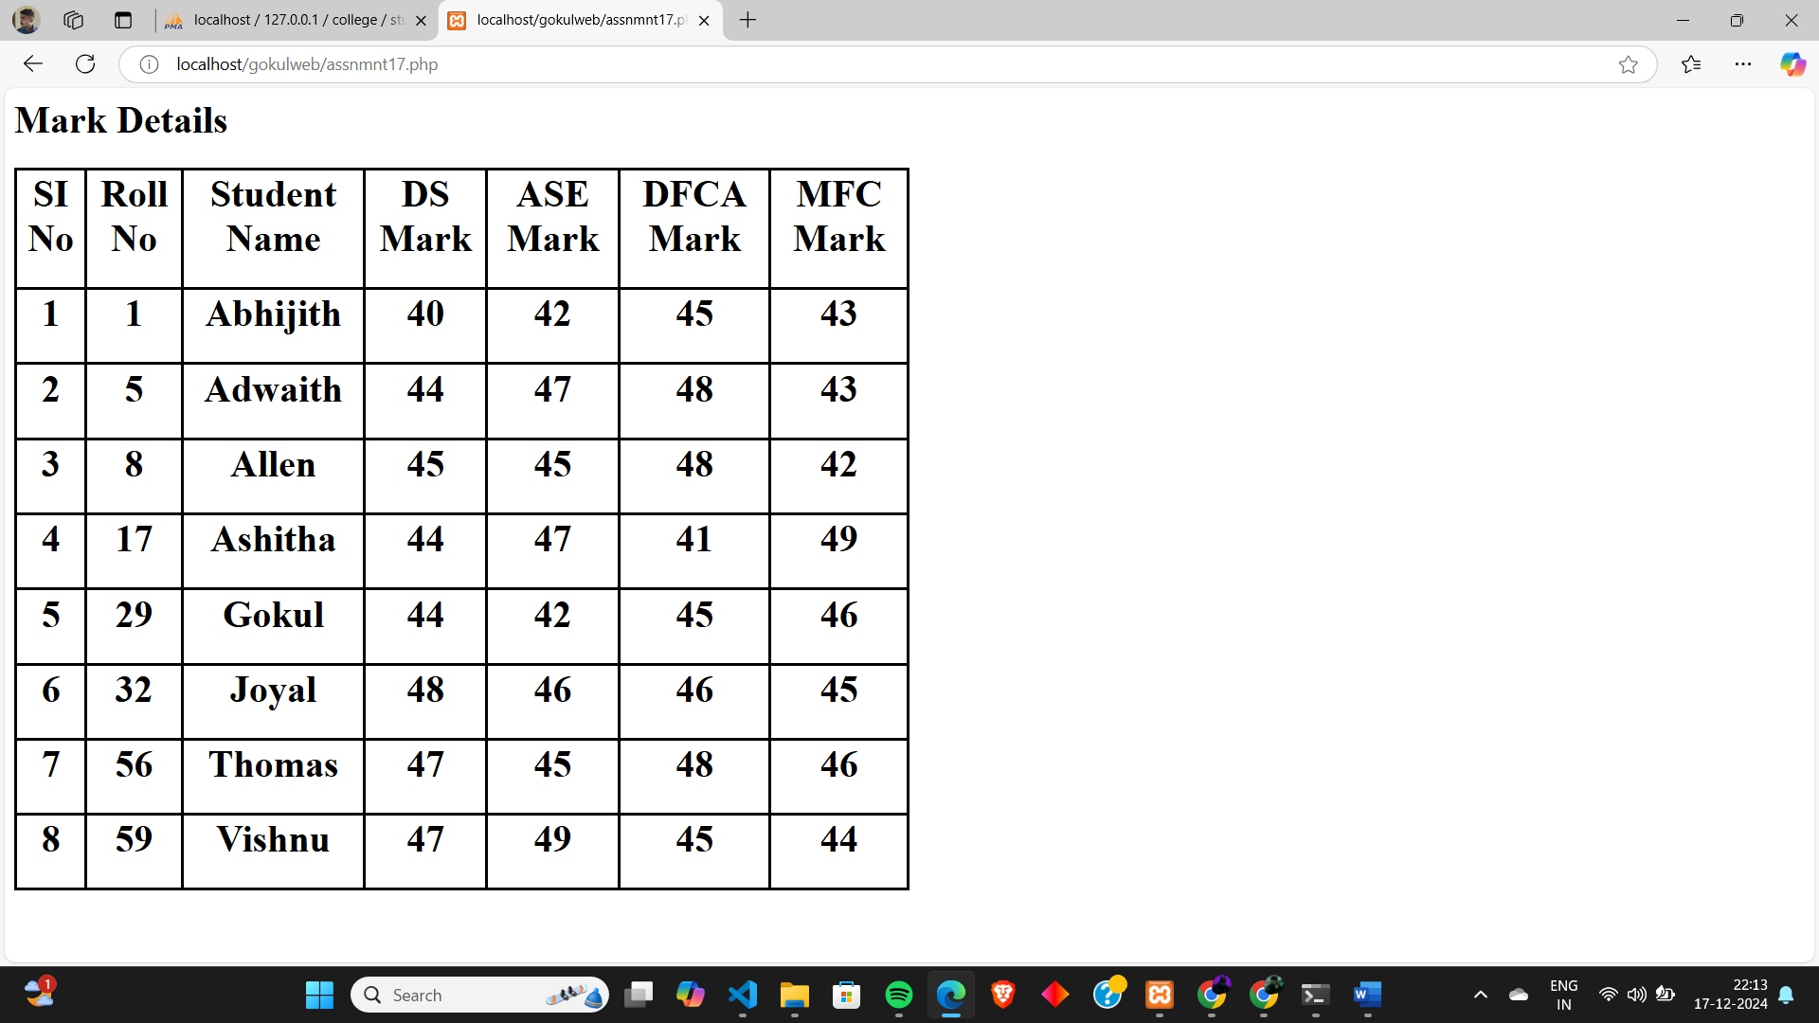

**CO5: Develop Web Applications**

**Program # 18**

Develop an application in PHP and MySQL, to accept book details viz.Book id, title, authors, edition and publisher from an HTML form in a web page and save the records in a database and to search for a book using the author name and display the search results

**PROGRAM CODE:**

**bookapplication.php**

<html>

<head>

    <style>

        body {

            font-family: Arial, sans-serif;

            text-align: center;

            padding: 50px;

            margin: 0;

            height: 100vh;

            display: flex;

            justify-content: center;

            align-items: center;

            background-color: #f4f4f4;

        }

        .container {

            max-width: 600px;

            margin: 0 auto;

            background-color: #fff;

            padding: 20px;

            border-radius: 10px;

            box-shadow: 0 0 10px rgba(0, 0, 0, 0.1);

            width: 1000px;

            height: 400px;

        }

        button {

            font-size: 20px;

            padding: 15px 30px;

            margin: 20px;

            cursor: pointer;

            background-color:rgb(173, 70, 6);

color: white;

            border: none;

            border-radius: 10px;

width: 250px;

            height: 70px;

        }

    </style>

</head>

<body>

    <div class="container">

        <h1>Online Book</h1>

        <button onclick="window.location.href='newbook.php'">Enter Book</button>

        <br>

        <button onclick="window.location.href='viewbook.php'">View All Book</button>

        <br>

        <button onclick="window.location.href='searchbook.php'">Search Book</button>

    </div>

</body>

</html>

**newbook.php**

<html>

<head>

<style>

        body {

            font-family: Arial, sans-serif;

            margin: 0;

            padding: 20px;

            background-color: #f4f4f4;

        }

        h1 {

            text-align: center;

            color: #333;

        }

        .container {

            max-width: 600px;

            margin: 0 auto;

            background-color: #fff;

            padding: 20px;

            border-radius: 10px;

            box-shadow: 0 0 10px rgba(0, 0, 0, 0.1);

        }

label {

            font-size: 18px;

            margin-bottom: 10px;

            display: block;

}

        input[type="text"] {

            width: 96%;

            padding: 10px;

            margin: 10px 0 20px 0;

            border: 1px solid #ccc;

            border-radius: 5px;

            font-size: 16px;

        }

        input[type="submit"] {

            width: 100%;

            padding: 10px;

            margin: 10px 0 20px 0;

            border: 1px solid #ccc;

            border-radius: 5px;

            font-size: 16px;

        }

    </style>

</head>

<body>

<?php

$servername="localhost";

$username="root";

$password="";

$dbname="college";

$conn=mysqli_connect($servername,$username,$password,$dbname);

if(isset($_POST['submit']))

{

$bookid=$_POST['bookid'];

$booktitle=$_POST['booktitle'];

$bookauthor=$_POST['bookauthor'];

$bookedition=$_POST['bookedition'];

$bookpublisher=$_POST['bookpublisher'];

$sql="INSERT INTO book (`book_id`, `book_title`, `book_author`, `edition`, `publisher`) VALUES('$bookid','$booktitle','$bookauthor','$bookedition','$bookpublisher')";

if(mysqli_query($conn,$sql))

{

echo "<script>alert('New Record Created Successfully');</script>";

}

}

mysqli_close($conn);

?>

<div class="container">

<h1>Enter Book Details</h1>

<form method="POST" action="<?php echo $_SERVER['PHP_SELF'];?>">

<label for="bookid">Enter Book Id:</label>

<input type="text" id="bookid" name="bookid" placeholder="Enter Book Id">

<label for="booktitle">Enter Book Title:</label>

<input type="text" id="booktitle" name="booktitle" placeholder="Enter Book Title">

<label for="bookauthor">Enter Author Name:</label>

<input type="text" id="bookauthor" name="bookauthor" placeholder="Enter Author Name">

<label for="bookedition">Enter Book Edition:</label>

<input type="text" id="bookedition" name="bookedition" placeholder="Enter Book Edition">

<label for="bookpublisher">Enter Publisher Name:</label>

<input type="text" id="bookpublisher" name="bookpublisher" placeholder="Enter Publisher Name">

<input type="submit" name="submit" value="Add Book">

</form>

<form action="assnmnt18.php" method="post">

<input type="submit" name="submit" value="View Home">

</form>

</div>

</body>

</html>

**viewbook.php**

<html>

<body>

<style>

table, th, td {

  border: 3px solid black;

  border-collapse: collapse;

}

</style>

<body>

<h1>Book Details</h1>

<?php

$servername="localhost";

$username="root";

$password="";

$dbname="college";

$conn=mysqli_connect($servername,$username,$password,$dbname);

$sql="SELECT * FROM book";

$res=mysqli_query($conn,$sql);

echo '<table style="width:50%">

<tr>

<th><h1>SI No</h1></th>

<th><h1>Book Id</h1></th>

<th><h1>Book Title</h1></th>

<th><h1>Author</h1></th>

<th><h1>Edition</h1></th>

<th><h1>Publisher</h1></th>

</tr>';

while($row=mysqli_fetch_assoc($res))

{

echo

'<tr>

<th><h1>'.$row["si_no"].'</h1></th>

<th><h1>'.$row["book_id"].'</h1></th>

<th><h1>'.$row["book_title"].'</h1></th>

<th><h1>'.$row["book_author"].'</h1></th>

<th><h1>'.$row["edition"].'</h1></th>

<th><h1>'.$row["publisher"].'</h1></th>

</tr>';

}

echo '</table>';

?>

</body>

</html>

**searchbook.php**

<html>

<head>

<style>

        body {

            font-family: Arial, sans-serif;

            margin: 0;

            padding: 20px;

            background-color: #f4f4f4;

        }

        h1 {

            text-align: center;

            color: #333;

}

        .container {

            max-width: 600px;

            margin: 0 auto;

            background-color: #fff;

padding: 20px;

            border-radius: 10px;

            box-shadow: 0 0 10px rgba(0, 0, 0, 0.1);

        }

        label {

            font-size: 18px;

            margin-bottom: 10px;

            display: block;

        }

        input[type="text"] {

            width: 96%;

            padding: 10px;

            margin: 10px 0 20px 0;

            border: 1px solid #ccc;

            border-radius: 5px;

            font-size: 16px;

        }

        input[type="submit"] {

            width: 100%;

            padding: 10px;

            margin: 10px 0 20px 0;

            border: 1px solid #ccc;

            border-radius: 5px;

            font-size: 16px;

        }

        table, th, td {

  border: 3px solid black;

  border-collapse: collapse;

}

    </style>

</head>

<body>

<div class="container">

<h1>Search Book</h1>

<form method="POST" action="<?php echo $_SERVER['PHP_SELF'];?>">

<label for="bookauthor">Enter Author Name:</label>

<input type="text" id="bookauthor" name="bookauthor" placeholder="Enter Author Name">

<input type="submit" name="search" value="Search Book">

</form>

<form action="assnmnt18.php" method="post">

<input type="submit" name="submit" value="View Home">

</form>

</div>

<?php

$servername="localhost";

$username="root";

$password="";

$dbname="college";

$conn=mysqli_connect($servername,$username,$password,$dbname);

if(isset($_POST['search']))

{

$bookauthor=$_POST['bookauthor'];

$sql1="SELECT * FROM book WHERE `book_author`='$bookauthor'";

$res=mysqli_query($conn,$sql1);

$totalrows=mysqli_num_rows($res);

if($totalrows==0)

{

echo "<script>alert('No Book Found');</script>";

}

else{

    echo '<center>';

    echo '<br><br>';

    echo '<table style="width:50%">

    <tr>

    <th><h1>Book ID</h1></th>

    <th><h1>Book Title</h1></th>

    <th><h1>Book Edition</h1></th>

    <th><h1>Publisher</h1></th>

    </tr>';

    while($row=mysqli_fetch_assoc($res)){

    echo

    '<tr>

    <th><h1>'.$row["book_id"].'</h1></th>

    <th><h1>'.$row["book_title"].'</h1></th>

    <th><h1>'.$row["edition"].'</h1></th>

    <th><h1>'.$row["publisher"].'</h1></th>

    </tr>';

    }

    echo '</table>';

    echo '</center>';

}

}

mysqli_close($conn);

?>

</body>

</html>

**Table**

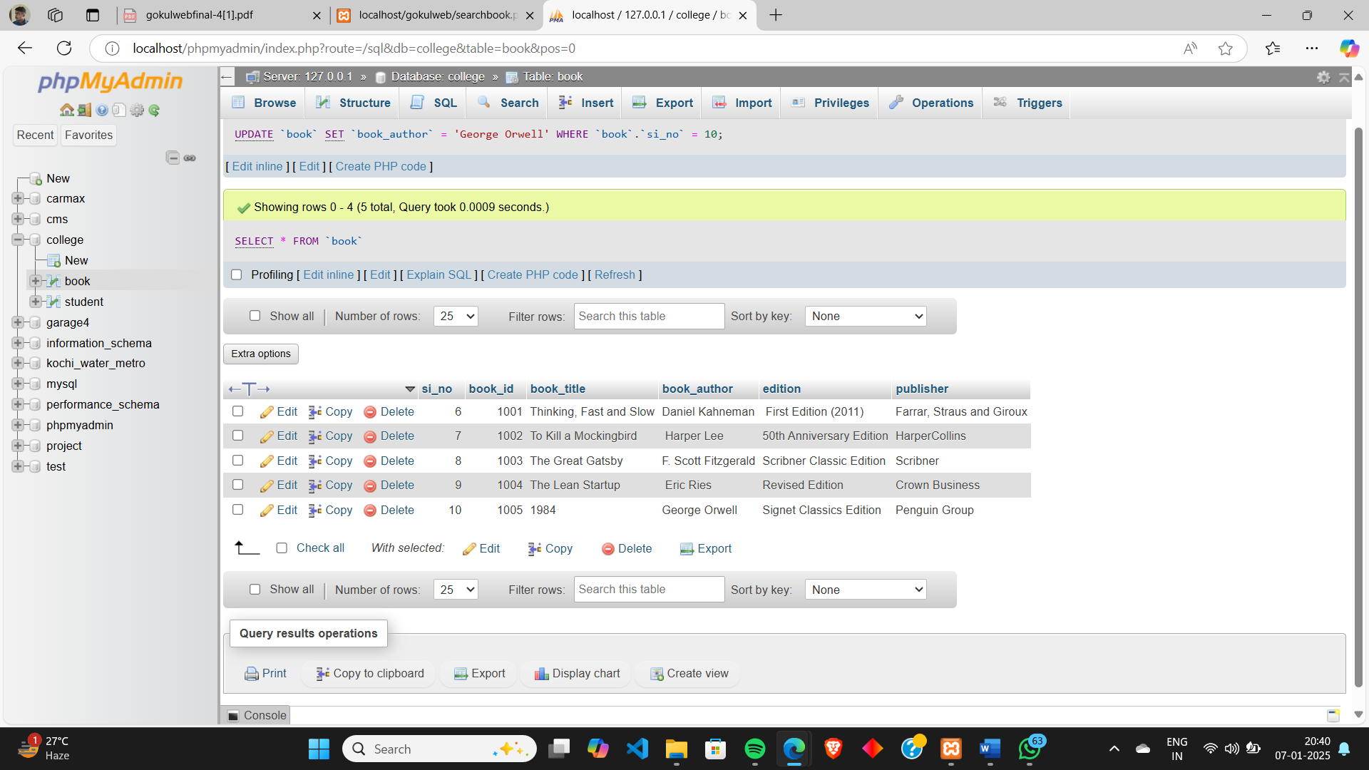

**OUTPUT:**

